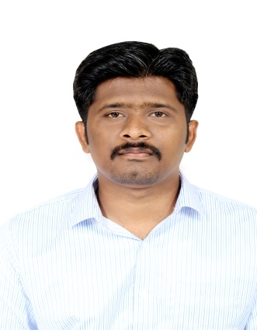

VISHNU

VISHNU.323771@2freemail.com

CAREER OBJECTIVE
Aspiring a challenging career, where I can effectively contribute my skills as business professional, possessing competing financial skills and experience in an environment that promotes continual upgrading of knowledge with strong opportunity for advancement within the organization.

WORK EXPERIENCE:

- From Sep 2016 to June 2017 worked in Sodexo Food Solution India Pvt Ltd
(Principal Employers: Lakshmi Machine Works/ ELGI Equipment’s, Coimbatore, TN, India) as Administrative Assistant.

Roles and Responsibilities:
- Provide general administrative and clerical support including mailing, scanning, faxing and correspondence memos to management.
- Perform data entry and scan documents. receive, sort and distribute mail
- Receive and process deliveries
- Interact with visiting vendors.
- Generate reports and other documents.
- Maintain office procedures including contact information, directions and frequently requested company information.
- Monitor sales reports, process expense reports for sales staff, Verify orders.
- Liaise with executive and senior administrative assistants to handle requests and queries from senior managers
- Worked at KOTAK MAHINDRA PRIME LIMITED (Ivangel Sales And Services) as an Associate in Branch operations at Coimbatore (Tamil Nadu) branch from Aug 2013 to July 2016.

PRODUCT: New car, Used car, Prime Vishwaas, Refinance and etc
Roles and Responsibilities:
- Insert Applicant and Co Applicant data by inputting text based and numerical information from source documents within time limits.
- Compile, verify accuracy and sort information according to priorities to prepare source data for computer entry.
- Review data for deficiencies or errors; correct any incompatibilities if possible and checking the outputs.
- Research and obtain further information for incomplete documents.
- Applying data programming techniques and procedures.
- Generate reports, store completed work in designated locations and perform backup operations
- Scan documents and print files, when needed
- Keep information confidential
- Respond to queries for information and access relevant files
- Comply with data integrity and security policies
- Ensure proper use of office equipment and address any malfunctions

EDUCATIONAL QUALIFICATION

- B.Sc., (Information Technology) in Sri Ramakrishna Mission Vidyalaya College of Arts and Science, Coimbatore (Bharathiar University) Year of passing 2013.

ADDITIONAL ACADEMIC DETAIL:

- Completed Microsoft Digital Literacy Certificate Test

COMPUTER PROFICIENCY:

- Professional Training in Computer Basics.
- Strong Microsoft Office skills, proficient in Excel
- Proficient in using Internet.
- Professionally Trained personnel in MS-Excel 2007, and much more experienced bank internal software’s and Lean Training as well
- Platform- Windows 98, 2000, XP, Windows 8.

KEY SKILLS:

- Willing to learn, Organization, Ability to work under pressure
- Do it now attitude, Initiative, self-motivated

PERSONAL PROFILE:

Date of Birth : 29-10-1992
Gender : Male
Marital Status : Single
Nationality : Indian
Languages Known : English, Malayalam, Tamil

DECLARATION:
I hereby declare that all the information provided by me is factual and correct to the best of my knowledge and belief.

