CURRICULAM
VITAE
PERSONEL INFORMATION

OBJECTIVE:
- To join a professional team in the field of Telecommunication Engineering and Information Technology to enhance my knowledge and professional skills within a dynamic and progressive environment where sincerity and dedication are pre-requisite.

Date of Birth:
30th March 1992

Nationality:
Pakistani

E-mail Address:
Amin.325032@2freemail.com
Amin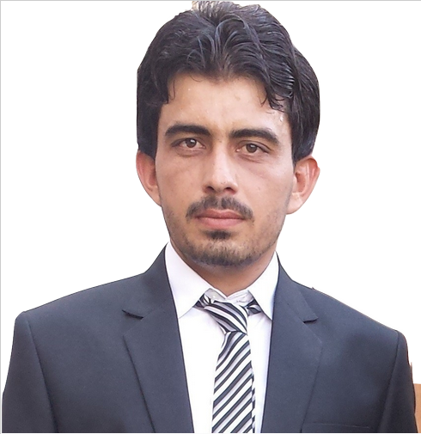
BE (Telecommunication Engineering)

EDUCATIONAL HISTORY

BE (TL):HAMDARD UNIVERSITY KARACHI
BE (Telecommunication Engg),
CGPA3.36
Intermediate:Govt.DegreeCollege No 1 (B.I.S.E D I Khan)
Pre-engineering, April 2011
Marks percentage71%
Matriculation:Qurtuba Public School andCollege(B.I.S.E
D I Khan)
Marks percentage70%

AWARDS/HONORS/GRANTS

4-years, fully-funded, National ICT R&D Fund Scholarship – 2011
Awarded by:
Ministry of Information Technology, Pakistan,
To pursue the degree of Bachelor of Telecommunication Engineering at Hamdard University, Main Campus, Karachi.
EXPERIANCE
- Internship at PTCL
(August, 2014 to September, 2014)
- Internship at UCE 4G Optimization
(10 September 2015 to 30 October 2015)
- Internship at NetKom RF 3G Karachi
( 10 December 2015 to 15 July 2016)
- Volunteer, convocation 2015 at Hamdard university.

FINAL YEAR PROJECT

- Fault Detection In Distributed Antenna System

SEMESTER PROJECTS
- Variable Power Supply
- DC Motor Speed control
- 4-bits Digital Comparator and Subtractor
- LED Chaser
- Counter Using Infrared Sensor & Parallel Port
- Trainer Design

SHORT COURSE

- CCNA Training
Organized by:
Assistant Professor
Farhan Tanwir Hamdard Institute of Information Technology,Hamdard University, Karachi.

HOBBIES
- Sports
- Reading Books (Science, technology and Islamic)
- Reading News Paper

TECHNICAL KNOWLEDGE
HARDWARE:
Microcontrollers: 8051/89C51.
Arduino. Due
OPERATING SYSTEMS:
WINDOWS (XP, 7, 8, 8.1).
SOFTWARE TOOLS:
VISUAL STUDIO
PACKET TRACER
MATLAB
MULTISIM
LABVIEW
AUTOCADE
LANGUAGES:
C/C++
Assembly
Object oriented programing
Databases:
MYSQL
SQL

COMMUNICATION
- English
- Urdu
- Pashto:

