CARRICULAM VITAE
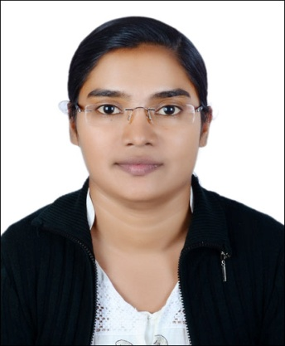

RAJI

RAJI.326106@2freemail.com

EMPLOYMENT VISA

Availability: Immediate

CAREER OBJECTIVE:

Seeking a challenging career that will enable me to utilize my competence to work with the growth oriented organization, which adequately utilizes my strong analytical and technical skills.

JOB DESCRIPTION:

Able to work on several campaigns at once, sometimes under pressure, and often on tight deadlines."

EDUCATIONAL QUALIFICATIONS:

- BACHELOR OF ARTS:ENG
(Mahatma Gandhi University Kottayam, Kerala India)

- Senior Secondary School Examination
(Mar Thoma College Thiruvalla Kerala India)

- Secondary School Leaving Certificate S.S.L.C
(Abraham Memorial High School Thirumala, Kerala, India)

- Computer Diploma(6 months course certificate)
LANGUAGES KNOWN:

- English, Hindi, Tamil & Malayalam.
- Arabic(speak)

TECHNICAL QUALIFICATIONS&SKILLS:

- MS Office Excel-Advanced
- MS Outlook-
- Data Entry Work(45PW)
- Internet & Software Usage &Letter drafting
- Software usage(symex,Neemsoftware(TMS/AGP),TELESALES,DMS/CMS
- Cash dealings(Petty cash/cash/flows
- Telephone Operator/attending, reception
- Secretarial work
- Telecalling&Customer&Service Experience

WORK EXPERIENCES&HISTORY:

- Working as an Accountant cum Manager in a Transportation company MUSAFAH(HARMAN STAR TRANSPORTATION)from 2015 onwards
- Worked as a Branch In charge in ALBADER ECCHANGE MADINAT ZAYED BEDA ZAYED,ABUDHABI from May 2013 to 2014
- Worked as an Archive Clerk&CustomerService in AL BADER EXCHANGE , MADINAT ZAYED,Western Region (Beda Zayed) ABUDHABI, U.A.E, from 2011 to 2013
- Worked as a Supervisor cum Receptionist in a Govt.Hospital SAUDI ARABIA (SABT AL ALAYA HOSPITAL) from 2010 to2011
- Worked as a DATA ENTRY OPERATOR in a GOVT.Sector(CONTRACT BASIS) VIKAS BHAVAN.TVM KERALA 2009-2010
- Worked as a Teacher in a Private School in Rajasthan (Bethel Public School, Ramganjmandi Rajasthan India) from July 2004 to May 2009
- Worked as a Receptionist cum Secretary in a reputed ISC/ICSE English Medium School in Pathanamthitta (Bethany Academy -Vennikulam P T A Kerala )from July 2002 to 2004

RESPONSIBILITIES:

- Good in communication so as to keep strong relationship with customers.
- Able to handle work simultaneously at a time.
- Extremely hard working and self-motivating.
- Maintains payroll information by collecting, calculating, and entering data.
- Providing administration related support to all departments as required.
- Fax, scan and photocopy of documents as required.
- Manage walk-in customers and handle their inquiries.
- Knowledge of administrative and clerical procedures and systems
- Customer service orientation

PROFESSIONAL EXPERIENCE:
- Give Presentation and demonstration to the customers.
- Good in communication so as to keep strong relationship with customers.
- Able to handle work simultaneously at a time.
- Preparing the financial statements and reports of operations, expenditure reports, statistical data, and other information concerning financial requirements.
- Reviewing, analyzing, presenting the financial data, including revenue projections & expenditure reports.

PERSONAL DETAILS

Date of birth : 08/02/1981

Nationality : Indian

Religion : Christian

Sex : Female

Marital status : Married

DECLARATION:

I hear by declare that all the information presented above is true to the best of my knowledge and belief.

