RESUME
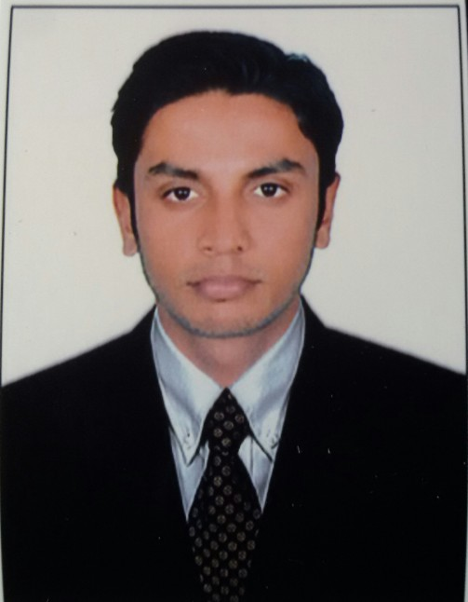

Dubai : Sharjah

Career Objective:
A dynamic M.Com professional with more than 3 years of Accounting experience, On MNC Company, seeking a rewarding career in a progressive, professional and transparent organization, in the field of Finance & Administrative sector, whereby I would contribute growth of the organization and development.
PROFESSIONAL STRENGTHS:
- Innovative: Make changes, introduction of something new.
- People-oriented: Enjoy working/being with people.
- Versatile: Turning easily or readily from occupation/job to another, changeable.
PROFESSIONAL EXPERIENCE:
Thomson Reuters India Pvt Ltd: Position held - Associate Content Analyst. Period from 22/09/2014 to 30/09/2016.
The job profile includes:-
- Analysis of Financial reports of the companies (Press Releases, 10Ks and 10Qs, etc) and updating I/S, B/S, C/F and other relevant data into the product.
- Segmental and Geographical analysis of the revenue, expenses and net income of the company.
- Analyzing the effects of any right issue, share consolidation and splits on the current share and dividend per share.
P.Chandra Mohan Hande Charted Accountant Office: Position held – Accountant / Audit Assistant - period from 1/4/2011 to 30/06/2012.
Roles & Responsibilities:
- Controlling Payable and verifying monthly supplier ageing reports.
- Recording invoices in system and Reconciliation of customers & vendors statement of a/c.
- Reconciliation of various General Ledger account.
- Preparation of clients -Trial Balance, Profit and Loss a/c and Balance Sheet.
Education Summary
Curriculum | Institution | Yearof Passing | Class
MCOM( Finance) | Canara College, Mangalore | 2014 | First
BCOM(Finance) | Govt. First Grade College Thenkanidiyoor, Udupi. | 2012 | Second

Computer Skills
- Accounting Software : Tally ERP9,
- Operating System : Microsoft Windows,
- Database : MS Access, Outlook, Word, PowerPoint
- Office Suite : MS Office, Excel.

ACHEIVEMENTS

- Was rated as OUTSTANDING for all the appraisals given so far.
- Received appreciation from clients and mangers for finding right bottlenecks and completing the tasks within the required timelines.

PERSONAL INFORMATION

Date of Birth : 19-9-1990
Gender : Male
Marital Status : Single
Languages : English, Hindi, Kannada, Malayalam, Tulu
Nationality : Indian
Present Address : Sharjah
Visa Status : Visiting Visa

Declaration –
I hereby declare that all the above information mentioned is true to the best of my knowledge.

Date:

