Sufiyan
Sufiyan.327177@2freemail.com
~ Mechanical Engineer ~ Precision Engineering, Hindustan Aeronautics Limited, HAL Bangalore
Key Skills  Building Codes & Standards  Plumbing/ Drainage Operations  Fire fighting Operations  Material Submittal Documentation  Heat Ventilation & Air conditioning  Communication Skills  Team Building & Leadership  Flexibility  Quick Learner | A versatile, high-energy professional with the merit of executing prestigious projects safely in large magnitude within strict time Schedules, Less Risk Assessment.
 | Profile Summary
- I consider myself a responsible, creative, with initiative and punctuality, I accept with pleasure the challenges and goals that your organization could assign me, with good handle of the interpersonal relationships, ability to work in teams, ability to work under high pressure, so as to solve problems efficiently and achieve the goals set by the company and my work group.

- Expertise in managing the successful rollout of project operations with answerability of defining scope, setting timelines, analyzing requirements, prioritizing tasks and identifying dependencies as per pre-set budgets

- Hands-on experience in fire prevention and inspection activities, equipment maintenance, and imparting training related to all phases of fire suppression, prevention, inspection, rescue & emergency operations

- Proficient in managing various activities like plumbing-drainage, firefighting, heating, ventilation and air conditioning operations as well as the preparation of material submittals
- Skilled in managing end-to-end testing & commissioning operations to reduce downtime & enhance operational efficiency
- Experienced in Team handling capacity.
- A result-oriented individual with strong analytical, communication, interpersonal and organizational skills

Certifications:
- Certified a course in NEBOSH Health and Safety at Work (HSW) from NIST Bangalore.

- Certified a course in Programming in C & C++ from NIIT, Mysore.

- Certified a Practicum Internship in RANE (MADRAS) Ltd, Mysore.

Career Timeline
Mechanical Engineer (Safety Engnr) Precision Engg HAL Post Bangalore
TEE VEE ESS Wire Products Mysore Industrial Area as Production Engineer
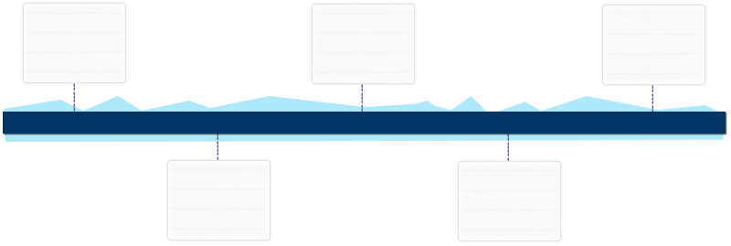
Certified a Course from NIIT for programming in C & C++
Certified a Course in Rane(MADRAS)Ltd
As Practicum Internship Course

Aug’12- Jul’13
Jul’07-Jul’27
Jul’15- Aug’16
Jul’15- Jun’15
Oct’24- Oct’29
Certified a Course from NEBOSH HSW from NIST Institute Banglr

Education
- Bachelor of Mechanical Engineering from Maharaja Institute Of Technology Mysore,VTU University, Belgavi in 2015
Work Experience
Jul’15- Aug’16 with Precision Engineering, Hindustan Aeronautics Limited HAL Post Bangalore.

Aug’12-Jul’ 13 with TEE VEE ESS Wire Products, Manufacturing of Chain Links, Mesh Fencing, Barbed Wire and Steel Fabricators. Dealer of TATA Wiron.

Roles and Responsibilities:
- Following standards Procedures for proper escalation of unresolved issues for appropriate internal teams.
- Ensure Proper recordings and closure of all issues.
- Managed the material quantity take-off; provided assistance in testing & commissioning operations.
- Preparing accurate timely reports.
- Exceptional skills in working in a high-pressure environment

Significant Accomplishments:
- Study underwent for some template tools to make a finish tool and proper pressure for Executing major International projects through measures such as proper planning, Design and execution which resulted in significant benefits to the company.

Aug’12- Jul’13 with TEE VEE ESS Wire Products Manufacturing of Chain Links, Mesh Fencing, Barbed Wire and Steel Fabricators. Dealer of TATA Wiron Mysore.
- Performed and observed various machining operations enthusiastically by doing such work.
- Extended support in maintaining the production line with timely reports.
- Coordinated with coworkers on all issues related to machining operation.
- Completing all duties according to applicable safety measures and published procedures.

Jul’15- Aug’16 with Precision Engineering Hindustan Aeronautics Limited (HAL) Bangalore.
Key Result Areas:
- Contributed in preparing and developing a project specification with colleagues often including those from other engineering disciplines.
- Planning and Designing new Production Processes.
- Considering the Implications of issues such as cost, safety and time constraints.
- Monitoring and Commissioning plant and systems.
- Ensuring there are safety messages in each incident action plan.
- Ensure Preparation and implementation of site safety and Health Plan.

Projects Handled

Project Title: “Study tooling concept for manufacturing of complex co cured composite structures “National Aerospace Laboratories (NAL) Bangalore India.
An attempt was made to fabricate a flexible tool used for curing of channel of Main landing Gear (MLGD) Door which makes use of carbon fiber reinforced material, epoxy resin, silicon rubber, hardener and accelerator using processes like hand-layup, de-bulking and curing. A study was conducted on various types of tools used for manufacturing the channel and in order to obtain a better insight about various factors to be considered while manufacturing a tool.

