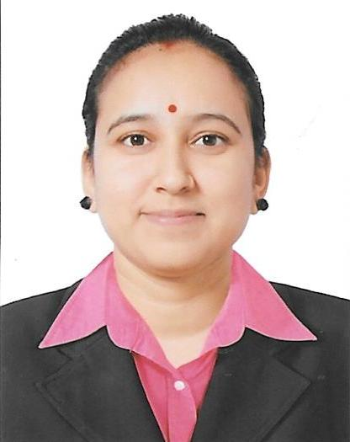
Curriculum Vitae
Priyanka
Priyanka.328025@2freemail.com

CAREER OBJECTIVE:
To pursue a career that leads to professional and personal development in a dynamic organization, values its human resource and rewards performance and where I can utilize and improve my professional skills in an effective way.
EDUCATION QUALIFICATION:
- MBA: HR + MARKETING - 2014
ITM COLLEGE, JIWAJI UNIVERSITY GWALIOR, INDIA
- Processional in human resources certificate ( PHR)
- DIPLOMA OF COMPUTER APPLICATION : -2016
COMPUTER
Active Education Institute, Lalitpur, India

- BACHELOR OF COMMERCE: FINANCE - 2012
Bundelkhand University Jhansi, India

- INTERMEDIATE: -2009
ECONOMICS
Girls Government Inter College, Lalitpur, India

- HIGH SCHOOL DIPLOMA: - 2007
Girls Government Inter College, Lalitpur, India
PERSONAL SKILLS:
- Human Resources Policies
- Sincere, honest and dedicate.
- Disciplined and sociable
- Hard working, self-motivated and result oriented
- Time Management
- MS Office Proficiency

PERSONAL INFORMATION:
Date of birth : 3rd Oct, 1992
Gender : Female
Marital Status : Married
Nationality : Indian
Stay of : Sharjah, U.A.E
Expire Date : 19th Nov, 2025

LANGUAGE SKILLS:
Hindi : Excellent
English : Good

PROFESSIONAL EXPERIENCE:
- Training at J.K tyre Interested in performance appraisal Process
- Organized various events at college fest
KEY STRENGTHS:
- Strong enters personal skills.
- Sound self correspondence.
- Effective oral communication.
- Ability to work under pressure.
- Able to work as own initiative.
- Good team player.
DECLARATION:
I hereby certify that the above information are true and correct to the best of my knowledge

