Selestian
Email: selestian.328358@2freemail.com
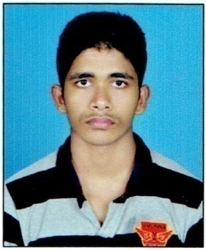

CURRICULUM VITAE

Career Objective

- To secure a position where my hard work, dedication and the ability to acquire new skills will advantage the organization I work for. I want to be a part of an organization that can provide me the opportunity to fulfill my sincere desire to augment my insight into my field of interest, gaining a substantial amount of experience

Academic Qualifications

Qualifications | Year of Passing | Institution | Board / University
PROFESSIONAL DIPLOMA IN INDIAN, FOREIGN AND SAP ACCOUNTING | 2016 | G-TECH COMPUTER EDUCATION KANHANGAD | THE INTERNATIONAL ASSOCIATION OF BOOKKEEPERS (IAB)
DEGREE | 2015 | PEOPLES CO-OPERATIVE ARTS AND SCIENCE COLLEGE, MUNNAD | KANNUR UNIVERSITY
12th | 2012 | GOVERNMENT HIGHER SECONDARY SCHOOL, BANDADKA | HIGHER SECONDARY EDUCATION
SSLC | 2010 | GOVERNMENT HIGHER SECONDARY SCHOOL, CHATTANCHAL | KERALA STATE BOARD

WORK EXPERIENCE IN INDIA

INSTITUTE :
WORK PROFILE : OFFICE SECRETARY
PERIOD : 1 YEAR
PLACE : KANHANGAD, KERALA

FIRM : KVR DREAM VEHICLES PVT. LTD
WORK PROFILE : ACCOUNTANT
PERIOD : 6 MONTHS
PLACE : KASARAGOD, KERALA

TECHNICAL STRENGTH

- Complete computer basic knowledge
- Professional Diploma in Indian, Foreign and SAP Accounting(PDIFAS)
Tally.ERP9
Peachtree
QuickBooks
SAP ACKA Accounting
Microsoft office

Strengths

- Extrovert person
- Sincere and hard working.
- Willing to take responsibilities.
- Positive attitude and determination to learn changes in my area of specialization.
- Have a good leadership quality
- Able to face challenges and difficulties

Hobbies

- Making friends and maintaining them.
- Listening Music.
- Reading.
- Travelling.

Personal Information

- Date of Birth : 18-9-1993
- Gender : Male
- Marital Status : Unmarried
- Nationality : Indian
- Languages Known : English, Malayalam

I hereby declare that the information furnished above is true to the best of my knowledge and belief.

Place : DUBAI SELESTIAN
Date : 24-12-2016

