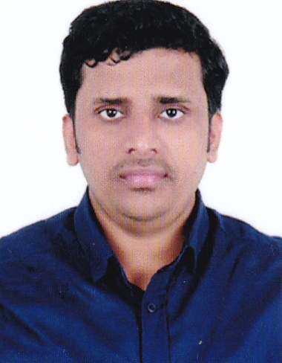  Alex  Email : alex.329643@2freemail.com  Place : Kochi, Kerala, India  PERSONAL DETAILS  Nationality - Indian  Date of Birth - 30/12/1990  Marital Status - Single  PROFESSIONAL SKILLS  - Excellent communication skill  - Team Player  - Creative problem solving.  - Punctual, self motivated and dedicated to job.  - Meeting Deadlines  - Multitasking  - Flexible and adaptable to changes  - Good Knowledge on Aeromodelling, Automotives. | RESUME  About me:  A highly motivated person looking for a challenging position where my proven abilities and skills will be utilized to enhance and bring optimum results.  Graduated in B Tech mechanical Engineering  Experience Summary:  Spare Parts officer - Saud Bahwan Automotive LLC, Oman: March 2013 to November 2016 ( 3.8 years )  Major Responsibilities  - Dealing with Automotive parts, Oils, Lubricants and Batteries of World Class brands like TOYOTA,LEXUS,HINO & DAIHATSU  - Using Electronic Parts Catalog of TOYOTA, DAIHATSU & HINO.  - Providing technical support to customer  - Follow-up with customers for orders and create additional sales opportunities  - Analyzing sales status of customers in regular intervals and make reports and presentations.  - Maintain optimum stock level  - Ensure that the quotations, sales orders, sales returns and application of customer discounts are performed as per the standard operational procedure.  - Follow-up for back orders with supplier.  - Co-ordination with Warehouse  - Checking the packed condition of goods and ensure that the packing is as per the requirements.  - Evaluate customer claims and advice warehouse for performance improvement  - Analysis of markets & employ marketing strategies to increase the revenue and profit of the organization.  - Co-ordinate logistics activities with cargo agents & logistics team and ensure that the goods are delivered to customer on time.  - Follow-up for payments, maintaining accounts of customers.  - Coordinating customs related operations with cargo agent.  - Keep proper records for future references.
Education:

Course | University/Board | Passing Year | Marks (%)
B tech | Cochin University | 2012 | 65
12 th | Kerala HSE | 2008 | 90
10 th | Kerala State | 2006 | 86

Technical Skills:

Operating Systems | Windows XP,7,8, Linux
Software | Photoshop, Open office, MS office

Projects:

- Developed an Amphibious aero plane

Training:

- FCI OEN Connectors Ltd. Kochi, India

I do here by declare that all the above information’s are true and correct to the best of my knowledge and belief.

