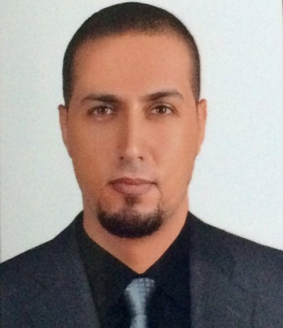
Hesham | Curriculum Vitae
Engineer supervisor maintenance 10 year's experience
Hesham.330497@2freemail.com
JUL 12 1984 /Nationality: Egyptian / Address : Alexandria / Marital status : single

Personal statement
A Highly ambitious and talented mechanical engineer with a comprehensive understanding of mechanical engineering processes. Throughout my career I have gained extensive knowledge of thermodynamics, product design and innovation and now aspire to reach a pinnacle point in my career and progress on to a senior engineering role. Committed to continuous professional development I aim to achieve optimal product quality by improving efficiency and component design. A significant part of my individual skills as a engineering professional is my ability to communicate concisely at all levels and motivate team members to enhance strategic goals and bottom line objectives. I am a proactive person who is always looking for the best possible outcome I have lots to offer in terms of intellect and enthusiasm and take pride in producing accurate work bringing uncompromisable standards to the workplace.
Professional Expertise
*Creative problem solving | *Risk analysis and development procedures | *Project co-ordination and management skills
*Defining and implementing manufacturing and production standards | *Working collaboratively with people from varied backgrounds to achieve a common goal | *Implementation of sales and marketing strategies
*Knowledge of fuel and energy types, material handling and heating and cooling processes. | *Engineering consulting | *Adhering to environmental health and safety initiatives
*Good knowledge of computers systems including all Microsoft packages | *Maintaining and updating records for management use | *Data Analysis

Academic Qualifications
Civil Aviation Of Metrology :September 2003 – September 2009
Senior Department engineer: Graduated September 2009
Bachelor Civil Aviation of Metrology Maintenance Aircraft engine and airframe
Human Resource Professional Association -March 2016 o July 2016
Driving license: Full clean driving license.

Work Experience
Zawayatech construction Jan 2016 – Feb 2017 ( MECHANICAL ENGINEER SUPERVISOR)
My role at zawaya tech Construction was a varied role where I undertook numerous responsibilities. This included overseeing the building process and detecting any errors, if necessary I would make amendments before the final examination. I regularly reported to management about work in progress, completed work and was actively involved in decision making. One of my key responsibilities was to coordinate deliveries with suppliers ensuring there was always adequate material available for the construction process.
- Liaising with management to ensure product quality objectives are obtained.
- Conduct procedure review and revision if required.
- Ability to prioritise tasks and execute in high pressure situations.
- Demonstrating team leadership & project management skills.
- Analyzing problems and providing a strategical solution.
- Providing information in a prompt and timely manner for management use.

IVECO Nov 2009 – Nov 2015 ( MAINTENANCE SUPERVISOR ENGINEER )
My key responsibilities as a maintenance supervisor engineer was to provide support and information to clients this often involved making follow up decisions based in the best interest of the client. I also conducted and supervised the maintenance of diesel engines ensuring procedures were performed in a safe manner following guidelines. Responsible for the planning of maintenance for all IVECO trucks I generated reports electronically and manually for managers use.
- Working effectively in a team oriented, collaborative environment.
- Supervising maintenance work carried out by others .
- Able to make wise field decisions and work with minimum supervision.
- Maintenance planning for all trucks according to company procedure.

LANGUAGES SPOKEN REFERENCES
-English Available on request
-Arabic

