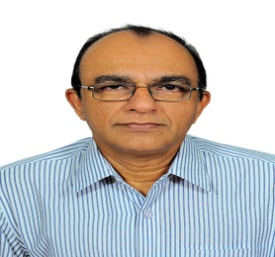
Jayapalan
Jayapalan.330598@2freemail.com

CAREER HISTORY
ADMINISTRATOR + HR & LOGISTICS – 1994 to 2016
Employers name - MESSARA TRADING CO. LLC, SHARJAH, UAE
Messara Trading has been the leading choice for Flooring ,Wall covering and Furniture in the Gulf.
Responsible for handling the day-to-day administrative tasks of the office and making sure that everything runs smoothly

DUTIES:
Administration responsibilities included maintaining an effective administration system, rapidly responding to and resolving any administrative problems, coordinating office procedures and Logistics, making sure that information is quick and easy to locate, ordering and maintaining office stationery and equipment, offering a warm and friendly welcome to any visitors, processing staff payrolls, keeping account of finances and updating staff files, raising and progressing purchase orders, booking travel and accommodation for senior managers, carrying out large volumes of filing while retaining a good level of accuracy and efficiency, Follow up the shipments and get the documents on time and arrange to clear the shipment according to the priority.
HR responsibilities included conducting preliminary interviews of candidates to various positions, maintenance of personnel files and assisting the Public Relations Officer dealing primarily with Visas for expatriate office and field force employees.

CHANDRAGUPT BOUTIQUES at Bombay International Airport Departure Lounge
Worked as a Showroom Manager for two years from 1988 to 1990.

RENACO ENGINEERING CONTRACTING, BAHRAIN
Worked as a secretary during 1983

ACADEMIC QUALIFICATION
Under graduate from Calicut University, Kerala, India.

COMPUTER PROFIENCY
Ms-Windows, Ms-Word, Ms-Excel.

PERSONAL INFO
Gender : Male
Nationality : Indian
Marital Status : Married
Linguistic proficiency : English, Hindi, Malayalam
Date of birth : 07/04/1957
Countries visited : USA, Germany, Qatar, Bahrain, Oman

REFERENCES
Available on request.

