Curriculum vitae

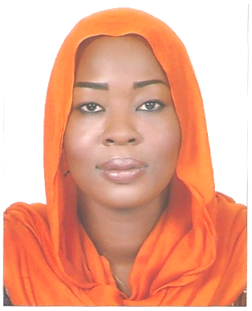
Contact Information:

Name: Dalia
E-mail: dalia.331158@2freemail.com

Personal Information:
Date of birth: 10th of July 1987
Place of birth: Abu Dhabi, United Arab Emirates
Nationality: Sudanese
Gender: Female
Religion: Muslim
Marital Status: Single
Visa Status: Resident
About Me:
- Very determined, enthusiastic and reliable.
- Full adaptation to work individually or as a team.
- Ability to bear work pressure
- High ability on communication and solving problems.
- Can establish an amiable and sociable relationship with fellow colleagues.
- Punctuality in attending work.

Career Objectives and Aims:
- To acquire deep understanding and gain hands on experience while working with a well established and reputed healthcare facility which enables me to get an opportunity to refine my skills and upgrade my career path.
- To enhance and develop my social skills such as communication and teamwork in a motivated and developing environment.

Educational Background:
- Primary school: The International School of Choueifat.
- Secondary school: The International School of Choueifat.
- High school: The International School of Choueifat (High school diploma, 2004), Abu Dhabi, United Arab Emirates.
- University: University of Medical Sciences and Technology, Faculty of Medical Laboratory Sciences, Department of Microbiology (B.Sc. General Degree [Excellent], 2008), Khartoum, Sudan.
- Sarah Institute of Science and Technology – International Computer Driving License (ICDL) certificate [English], 2011, Abu Dhabi, United Arab Emirates.
- Registered in the Sudanese National Council For Medical & Health Professions since 11/3/2012.
- Advance for Professional Development Center - Training Certificate for the American Society for Clinical Pathology International (ASCPi) examination for Medical Laboratory Sciences.

Work experience and Training:
- Yastabshiroon Private Hospital, Sudan.
- Academic Charity Hospital, Sudan.
- Al Ban Jadid Hospital, Sudan.
- Ahmed Gasim Children Hospital, Sudan.
(During university period from 2005 to 2008)
- The National Ribat University, Faculty of Medical Laboratory Sciences, Microbiology and Parasitology department, Sudan. (30/3/2009 – 30/3/2010)
- Al Khartoum Teaching Hospital, Sudan. (5/7/2010 – 5/8/2010)
- Sheikh Khalifa Medical City (Pathology and Laboratory medicine department - Microbiology), Abu Dhabi, UAE. (9/1/2011 – 24/3/2011)
- Enumerator on the Abu Dhabi Census (2011) government project conducted by the Statistics Centre from 4/9/2011 to 3/11/2011.
- Medical Secretary/ Insurance Coordinator at the Swedish Medical Centre from 1/7/2013 until 30/6/2014, Abu Dhabi, UAE.
- Medical Laboratory Specialist at Khartoum Teaching Hospital from 1/8/2015 until 19/10/2016.
- Medical Laboratory Specialist (part-time) at Fedail Hospital from 4/5/2016 until 17/10/2016.

Languages:
Arabic (First language): Fluent speaking and excellent writing.
English (Second language): Fluent speaking and excellent writing.

Skills:
- Good knowledge of laboratory specimens processing.
- Knowledgeable in laboratory management and quality control (QC).
- Common with medical terminologies.
- Well-informed in computer operations.
- Familiar with computer programs and applications (Word - Excel - PowerPoint - Access - Internet).
- Fast typing in both Arabic and English.
- Translating from English to Arabic and from Arabic to English.

