HR Admin cum Accounts
__________________________________________________________
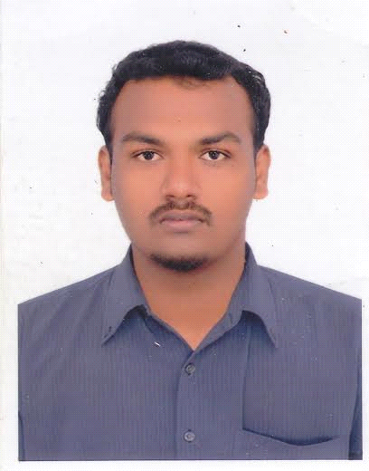

NAJIB
NAJIB.334310@2freemail.com

About VISA:
VISA Type - Visit VISA
VISA Duration - 11th January to 3 Months
______________________________________________________________________________
Career Objective:
Seeking a challenging environment that encourages continuous learning and creativity provides exposure to new ideas and simulates personal and professional growth.
_____________________________________________________________________________________

Professional Experience:

IRIS KPO Resourcing India Pvt Ltd (Jun 2016 – Dec 2016)

Period : June 2016 to December 2016
Role : Accountant / UK payroll.
Location : Chennai, India.

Roles & Responsibilities: Admin / Accountant

- Monthly salary calculation.
- Leave & Attendance Details.
- Maintaining Balance sheet
- Petty cash using Tally 9 ERP & MS-Excel.
- IRIS Software using for Employees Salary Calculation.
- Maintaining manually using MS Excel.
- Monthly Reports
        - Monthly Profit & Loss Reports
        - Balance Sheet Reports &
        - Client’s Reports.
CANARIES INDIA Pvt. Ltd. (Nov 2013 – Oct 2015)

Period : Nov 2013 to Oct 2015
Role : HR Payroll & Recruitment
Sub Role : Accountant
Location : Bangalore, India.

Roles & Responsibilities: HR Payroll & Recruiter

- Joining & Separation Formalities.
- Appointment Letter & Confirmation.
- Managing the Job Portal.
- Maintaining Company files, Documents & Persona, Details.
- Interviews & Recruiting.
- Employees, Employee Relation.
- Maintain Leave & Attendance Details.
- Updating Salary details, ESIC& PF.
- Handling the petty cash book.
- Handling Internal Issues.

BOSCH AND SIEMENS HOME APPLIANCES GROUP (May 212 – Oct 2012)
Period : May 2012 to Oct 2012
Role : Customer Support
Location : Chennai

Roles & Responsibilities: (Voice Process)

- Handling Compliant Calls
- Forward the Data's to Team Lead.
- Customer Demo Intro.
_____________________________________________________________________________________

Academic Qualification:

- Human Resource Management(Recruitment , Payroll) - 2013 - 2014
Canaries HRM Training Institute, Bangalore, India

- B.sc(Information Technology, Accounts) - 2009 -2012
From Jamal Mohamed College, Trichy, got 70.65% (Up to 6thsem)
Bharathidasan University, Tamil Nadu, India.

Certified Knowledge’s :
Tally.9.0 ERP – 3 Years Experience with professional knowledge.
MS Office – (MS Excel & Ms Word) well trained knowledge.
E-Mail – Quotations & Sales Proposals.
______________________________________________________________________________
Personal:
Date of Birth : 11th April 1992123
Sex : Male
Marital Status : Married
Nationality : Indian
Languages Known : English, Tamil, and Malayalam
Declaration:
I herewith solemnly and sincerely affirm that the statements and the information furnished above are true and correct to the best of my knowledge.

