RESUME
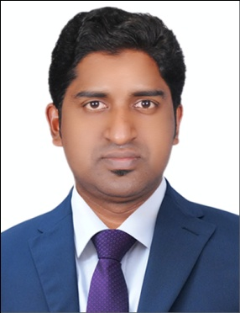  NIYAS  DHA PHARMACIST  Pharmacy Council | Career Objective  To secure a challenging position, which involves both, to work in a dynamic environment and to enhance my skills, knowledge and potential in building a bright career with skills capable of consistently producing top quality work through dedication and commitment and also to contribute to the organization success. Seeking a long-term relationship with the institution that provides ample potential for continuous learning and lateral growth. To be a dedicated and creative motivator with an excellent ability to learn new technical concepts. Good team player with strong analytical, organizational, interpersonal and Communication skills.  Academic Qualifications  COURSES NAME OF INSTITUTION BOARD / UNIVERSITY YEAR OF PASSING  B.Pharm University college of medical education Puthuppally Kottayam M G University, Kerala 2014  XIIth GHSS Edakunnam Kanjirappally Kottayam State Board 2009  Xth GHS Perinthalmanna Malappuram State Board 2007
My Strength

- Excellent communication and managing skills
- Positive attitude and hardworking
- Adaptable and innovative
- Leadership quality
- Punctuality

Academic Project and Seminar

B pharm level- a review on impact of neutraceuticals on health

Clinical Practice
General Hospital, Changanacherry [January 2014, 15 days]

Industrial Experience
As the part of B.Pharm curriculam visited SPINKA PHARMA,HYDERABAD and, to get familiarized with the technical aspects of production, R&D, QA, QC, GMP, HRD and MARKETING WINGS of the unit and to get first hand information and awareness about the industrial culture.

Languages Known

- English
- Malayalam
- Hindi
- Tamil

Personal Details

- Gender : Male
- Nationality : Indian
- Religion : Muslim
- Caste : islam
- Date of Birth : 28th March 1989
- Marital status : Single
- Blood Group : A+ve

Work Experience
- One year experience in Wockhardt Pharmaceuticals as Sales Executive in India.
- 8 month experience in Apollo hospitals Banerghetta Bangalore as Pharmacist.
- 8 month experience in life health care group as Pharma Executive

Declaration

I hereby declare that the above-furnished details are true to the best of my knowledge and belief and that I have neither concealed nor distorted any facts in this regard. I will be consistently contributing the best of my potential to the success of the corporate I serve.

