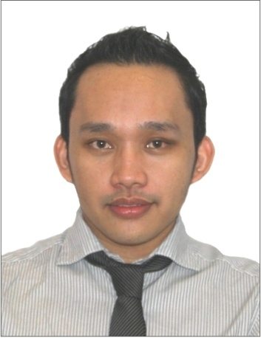
EDMOND
Email: edmond.335236@2freemail.com

Career Objective:
To share my knowledge’s, skills and abilities acquired from my educations, trainings and work experiences.

Profile:
- Fast learner, easily pick-up instructions and work with less provision.
- Team player in performing duties and responsibilities.
- Role model in doing task and decisions.
- Responsible, can manage time pressure and easily adjust work environment.

Work Experiences:

Company Name Position Date Coverage

Juma Al Majid Establishment Merchandiser Sept. 06, 2009- Jan. 11 - 2017
Dubai, U.A.E.
Wizz Retail Concepts L.L.C. Sales Assistant/ Sept. 17, 2005-Jun 15, 2009
Dubai, U.A.E. Visual Merchandiser
Tokumi Electronincs Philippines Inc. Cadet Engineer May 05, 2004-May 04, 2005
Clarkfield Pampanga, Philippines
Clark Data Data Encoder Sept. 09, 2003-Mar 07, 2004
Clarkfield Pampanga, Philippines
SM Electronic Appliances Sales Executive June 12, 2002-July 05, 2003
Pampanga, Philippines
KFC Fast Food Restaurant Service Crew Aug. 21, 2001-Feb. 27, 2002
Angeles Pampanga, Philippines
Coffee Overdose Coffee Waiter Nov. 14, 2000-June 13, 2001
Angeles, Pampanga, Philippines
Chowking Fast Food Restaurant Service Crew Nov. 07, 1999-Apr. 05, 2000
Clarkfield Pampanga, Philippines

Duties and Responsibilities (Merchandiser/Sales Assistant):

- Assists and prepare customer orders, needs and request.
- Listen and suggests new products that customer always ask.
- Preparation of receipts voucher, sales voucher, petty cash and cash flow.
- Handle cash register and monitor of float amount before and after the shift.
- Customer care always reminded productive relationships and satisfaction.
- Responsible on achieving sales and profit targets.
- Ensure product availability to avoid lost sales.
- Advance planning for any possible stock out.
- Allocates additional back-up items for any special events.
- Prepare list of slow moving goods to be sited to fast moving area.
- Ensure fast moving goods availability.
- Merchandise new items delivered.
- Maintain the storage and shop clean, convenient and in order.
- Replenish items in the designated place in the shop.
- Responsible for ordering and preparing all invoices of delivered items.
- Conduct physical counts and valuations of inventory.
- Give feedback/information to the management for the advancement of company.
- Assures that the weekly reports are been prepared and submitted on time.

Training and Seminar Attended (Dubai U.A.E.):

- Training for Customer Service (September 17-19, 2008).
- Guidelines for External Promoters in Dubai Duty Free (June 05, 2008).
- Reminders for External Promoters in Dubai Duty Free (June 05, 2008).

Seminar Attended (All in the Philippines):

- Seminar in Semiconductor Industry and Texas Instruments (January 08, 2003).
- Educational Fieldtrip at BAYANTEL and SKYCABLE (January 08, 2003).
- Educational Fieldtrip at Globe and Smart Telecom (January 09, 2003).
- Educational Fieldtrip at ABS-CBN 2 and other TV networks (January 09, 2003).
Education:
Bachelor of Science in Electronics and Communications Engineering
Holy Angel University, Angeles City, Philippines

Skills/Qualifications:
Computer Literate (MS Word, Autocad, Powerpoint and MS Excel)
Able to read, write and verbally communicate in English.

Personal Data:
Visa Status : Cancellation under process
Nationality : Filipino Civil Status : Single
Birthdate : November 26, 1980 Height : 5ft. 5in.

Character References:
Available upon request

I certify the above information is true and hereby authorize the company to verify said given information. I further agree if hired, to undergo the required pre-employment.

