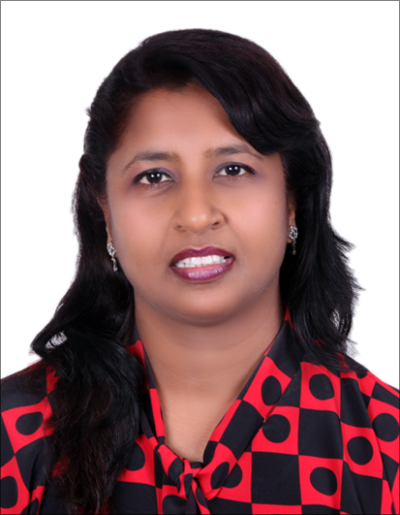
Joyce
Dubai, UAE
Email: joyce.336145@2freemail.com
Personal Statement

I am a professionally qualified educationist, with over 28 years experience in transforming and directing the lives of young children. Have built on the experience gained through my employment as a secondary school teacher, I am qualified to teach students from Grade 5 to 10 and support personal and academic development.

Education and Qualification

2006 Bachelors in Education Pune University
1988 Teachers Training Course Delhi University
1994 Bachelors in Arts Pune University

Teaching Experience

December 1995 – Till Date Maharashtra
June 1992 – Nov 1995 St. Jude’s High School, Dehu Road, Maharashtra
June 1989 – April 1992 Cresent High School, Pune, Maharashtra
June 1988 – April 1989 Hindustan Antibiotics High School, Pimpri, Maharashtra

Professional Profile

- Class Teacher for Grade 10.
- Subject Teacher for English, History & Political Science to students from grade 5 to 10
- Teaching Geography & Economics to students of grade 9th and 10th
- Hands on experience in lesson planning and assessment
- Used a range of interactive teaching methods to enhance learning & development skills for Grade 9 & 10.
- Monitored learning through a range of assessment techniques
- Developed strategies to deal with classroom behaviour
- Mentor & work with weak students on a one to one basis who are not able to understand or follow the syllabus in a regular class.
- Implemented various interactive methods to deliver subject knowledge to students and get them involved to participate and make learning more fun.
- Actively involved in various extra curricular activities for the school and have encouraged students to participate making them realize their various potentials.
- Yearly assignment from the Secondary School Board for checking 10th Grade answer sheets.

Extra Curriculum Experience

- Prepared students for the following Inter House and Inter School Competitions
- Elocution
Debate
- Singing
- Drama
- Been the Dean of St. Patrick’s High School since 2009 till date
- Organized and prepared students for sports activities and cultural activities in school
- Helped teenagers deal with various problems they face at home and school. Shared an excellent rapport with them
- Good organizing skills in arranging various school activities

Personal Details

Date of Birth 16th July 1969
Languages English, Hindi & Marathi
Visa Status Husband Sponsorship

