AMGAD

AMGAD.336275@2freemail.com 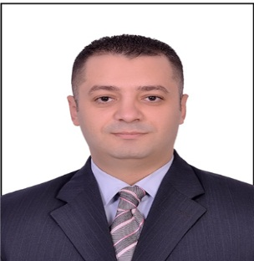

PERSONAL INFORMATION

Born 19 August, 1985 in Cairo (Egypt)
Citizenship: Egyptian
Military service: Exempt
Marital status: Married.

Summary

Responsible for managing a team of security personal to ensure the protection of the properties, guests, staff. Patrols building corridors, access, public areas and investigates the suspicious activity.

WORK HISTORY

12. 2014 - present Kempinski palm JUMEIRAH – Dubai
Security supervisor
- Telephone and reception/switchboard duties.
- Well dealing with UAE government civil defense, Dubai police, immigration and the CID
- Handling fire or emergency alarms.
- Develop and maintain list of appropriate police jurisdiction contacts.
- Carry out other duties as assigned by the Director of Corporate Security.
- Dealing with all the emergency issue and first aid if required.
- Incidents Reports writing.
- Dealing with incidents as and when required.
- Instructional and supervisory ability.
- Monitor security officers to enforce security/safety programs that enable the company’s assets to function according to the guidelines, quality standards, and operating objectives of the company and to ensure security provider is providing adequate supervision of security officers.
- Assist the Director of Corporate Security in the Analyzing of statistical data from the different law enforcement agencies.
- Implement security/safety improvements that benefit the company’s assets, visitors, tenants and employees as directed by Director of Corporate Security.
- Plan and Conduct Safety Awareness Meetings at all area assets annually.
- Respond to all security concerns from tenants and company personnel.
- Develop and maintain positive relations with tenants, contractors, local law enforcement, community and groups or associations that benefit the company.

04. 2012 – 12. 2014 Embassy of USA – egypt, CAIRO
Security supervisor
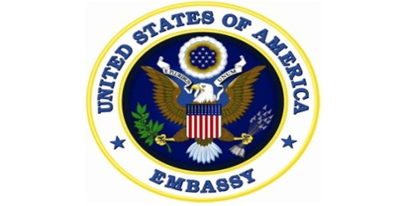
- Handling the watching CCTV and control room.
- Make security rounds in all the areas and ensure the general safety all vehicles and citizens chattels are in good conditions.
- All precaution in the emergency cases.
- Insure that safety and security procedures are followed.
- Take charge of the control room (Dispatcher) and monitoring all the movements all the time.
- Performs any duties as assigned by management MSG (Marine security guards).
- Assist embassy departments if required.
- Ensure that gate passes are issued for all items stocks that leave the embassy and each item to be logged in the register book.
- How to screen the cars.
- Monitoring the visitors and the contractors all the time.
- Sharing with all the embassy events.
- Monitoring the suspicious persons

07.2010 – 04.2012 kempinski nile hotel – egypt, Cairo
Security supervisor
- Monitoring the CCTV and control room.
- Respond to any fire / smoke alarm or emergency in the hotel and ready to act accordingly.
- Make security rounds in the cars parking area and ensure the general safety all vehicles and if they are correctly parked.
- Sharing in the opening of the hotel.
- All precaution in the emergency cases.
- Insure that safety and security procedures are followed.
- Take charge of the control room (Dispatcher) and monitoring all the movements all the time.
- Performs any duties as assigned by management.
- Assist hotel’s departments if required.
- Ensure that gate passes are issued for all items stocks that leave the hotel and each item to be logged in the register book.

EDUCATION

05.2004 – 07.2008 Advanced academy
B.s.c
- Administrative information system.
- Graduate project with good degree of using XP widows from the beginning till professionalism.

01.2001 – 12.2001 Kamal soilman
Secondary school

Qualifications
- General qualifications
- CCTV watcher, Dealer with the bomb threat calls, Fire panels, Hand Held Radios, Handling Complains, and Evacuation Drills.
- Responsible for the Daily Reports.
- Able to work under high pressure, hard worker, fast learner, team worker.
- Familiar with the metal detectors like hand held, gates, X-rays machines and car inspections.
- Familiar to reprogram all the locks for the door of guest rooms by device locks.
- Familiar to maintain and install software for any electronic safe box by the safe box device.
- Dispatcher at the control room.
- Aware of the main duties on all entrance and exits of all the building.
- Well informed by the hotel policy and procedures and patrolling system.
- Dealing with the special events & parties and handling Complains.
- Monitoring and guest or visitors at the building.

- Special qualifications
Department Administrator
- Dealing with incoming emails, posts and conducting correspondence with concern departments.
- Providing all necessary documents, briefing papers and preparing reports.
- Preparing duty schedules and submits it to the system (handling the vacations and days off for the departments’ team accordingly).
- Maintaining office layout supplying it with necessary stationeries and equipment's.
- Arranging the files and documents (hard/soft).
- Registering the monthly departmental meeting and preparing the required instructions, policies and procedures.
- Preparing the annual and analyzes reports.
- Preparing departmental job descriptions and action plans.

Public Relation officer
Government relations officer training (Hotel license, Visas procedures, DTCM and immigration)

primary responsibilities

- Protect a property, staff and guests.
- Maintan and update a property loss and prevention program.
- Perform servisec to ensure the safty and protection of the properties against loss or damage ,injury , harassment and fire.
- Establish and install key controls on departmental communication equipment and property accses.
- Evaluation incidents and determine cours of action.
- Discover sources of the security violations.
- Familiar with the full incident reportes.
- Maintain an emergance trining.
- Prepare and conducting information security & seafty trining.
- Monitor and supoort security-related processing for cleared staff.
- Supervise parking procedures.

certificates
- Two certified as an employee of the month (February 2011&2012) from Kempinski Nile Hotel.
- Certificate of appreciation (August 2013) from American embassy.
- Trauma first aid certificate (May, 2014) from American embassy.
- Superior honor award (November 2013) from the American embassy.
- Firefighting & safety certificate from Dubai civil defense.

Languages skills

- Arabic : Mother tongue
- English : Very good speaking and writing.

computer skills

- Microsoft office (ICDL 2010)
- HOT SOS (Hotel Service optimization System)
- Triton (Hotel Service orders System)

license

- Egyptian driving license (Cairo – valid till 2017).
- UAE driving license (Dubai – valid till 2024).
- Valid DPS license.
- Valid Gov. Relations license.

References

Available upon request

