PRADIPTA PRADIPTA.336913@2freemail.com

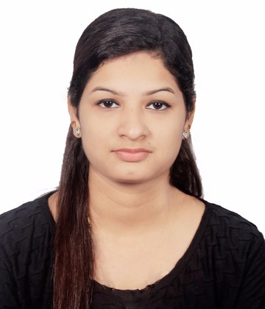

Personal Skills

- Good communication
- Self –Motivated
- Target Driven
- Initiative
- Resourcefulness
- Commitment

Computer Skills

- Windows/Mac OS
- Microsoft Office

Languages Known

- English
- Hindi
- Nepali
- Tamil

Hobbies/Interest

- Reading books
- Watching Cricket
- Listening Music
- Cooking

CARRIER OBJECTIVE

To work for a professional organization which offers challenging opportunities and utilize both my educational background and professional experience to contribute to the organization's noble and humanitarian goals and simultaneously provide excellent opportunities for career development and personal growth in the field of HUMAN RESOURCES MANAGEMENT.

EDUCATION & PROFESSIONAL DEVELOPMENT

Master Degree in Social work (Human Resource Management) from Pondicherry University, Pondicherry, India

CGPA: 8.67

Bachelor Degree in Commerce (Corporate Secretaryship) from A.A.S College, Pondicherry, India

Percentage: 72%

Higher Secondary School from Sri Sankara Vidhyashramam Hr. Sec. School, Pondicherry, India

Percentage: 96%

PROFESSIONAL EXPERIENCE

Company: GE (Oil & Gas), Coimbatore, India
Position: HR Coordinator
Period: 2015 – 2016

Job Profile

- Assist with day to day operations of the HR functions and duties.
- Provide clerical and administrative support to Human Resources executives.
- Compile and update employee records (hard and soft copies).
- Deal with employee requests regarding human resources issues, rules, and regulations.
- Assist in payroll preparation by providing relevant data (absences, bonus, leaves, etc).
- Communicate with public services when necessary.
- Properly handle complaints and grievance procedures
- Coordinate communication with candidates and schedule interviews.
- Conduct initial orientation to newly hired employees.
- Assist recruiters to source candidates and update the database.

PLACEMENT TRAINING AND INTERNSHIP

- Completed one month placement training in HR department at GE (Oil and Gas), Coimbatore branch, India.
- Underwent 15 days of Institutional Training at Hindustan Unilever Limited, Detergents Factory (Vadamangalam branch), Pondicherry, India.
- Undergone a month of concurrent fieldwork training at UCAL Fuel Systems, Pondicherry, India.
- Undergone a month of concurrent fieldwork training at an NGO named “Samugam Foundation”, Pondicherry, India.
- Undergone a month of concurrent fieldwork training under HR Department at Lucas-TVS Ltd, Pondicherry, India.

WORKSHOPS AND CONFERENCE

- Attended 3rd Annual Conference on Future Proofing HR on the month of March 2016 conducted by CHROMA (Chengai Human Resource Officers and Managers) at ITC Grand Chola, Chennai.
- Attended HR-Meet (Pondicherry Chapter meeting) conducted by NIPM (National Institute of Personnel management).
- Attended 7 days of workshop program on Soft Skill Development conducted by “TALKSHOP ACADEMY”, Chennai, India.
- Attended Employability Skills Development Program conducted by ICTACT, Pondicherry E-Governance Society.
- Attended one day workshop program on “Research Methods for Project Work In Social Work” conducted by Department Of Social Work, Pondicherry University.

CO-CURICULAR ACTIVITIES
- Worked as a member of Organizing Committee in State Level Hindi Literary Meet held at Achariya Arts and Science College.
- Worked as an Event Coordinator in Inter College Commerce Festival (Acharya Business League) held at Achariya Arts and Science College.
- Worked as a Program Committee Coordinator during Rural Camp, VELICHAM 2014 organized by Department of Social Work, Pondicherry University.

ACHIEVEMENTS

- Got job offer from Infosys BPO Ltd. Being shortlisted in campus interview in the year 2013.
- Awarded Department Topper Prize in “Know Your Economy Test” conducted for colleges by Scientific Research Association for Economics and Finance.
- Awarded with the title of “Amul Vidhya Bhushan” for outstanding performance in HSC exam (2011).
- Have participated in various inter college competitions and have bagged prizes.

DECLARATION

I hereby declare that all the details above furnished are true to the best of my knowledge and belief

