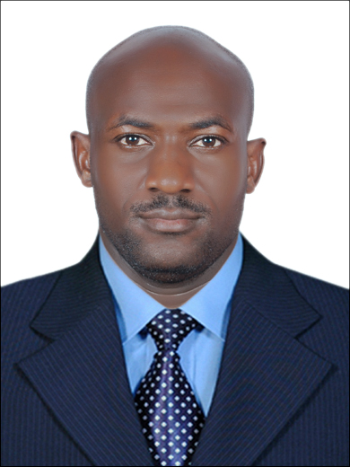SECURITY GUARD

Calvin
E-mail: calvin.339109@freemail.com

Professional profile

I am a dedicated straight forward individual who is hardworking and can work under minimum supervision. I like learning more from my superiors and seniors in order to attain a given goal and can work under pressure. I believe am trust worthy and have experience in security duty.

PERSONAL OBJECTIVE

Being a hardworking, result oriented, focused yet self-motivated person. Able to manage, organize and prioritize workloads in order to meet strict deadlines. I have excellent interpersonal sensitivity and thoughtful accuracy, ethics and integrity. A good team player and does well even in challenging situations. A strong communicator used to dealing with people at all levels.

PERSONAL INFORMATION

• NATIONALITY: UGANDAN

• DATE OF BIRTH: 10THOCT 1983

- Date of issue: 17TH MAY 2010

- Date of expiry: 17TH MAY 2020

• MARITAL STATUS: MARRIED

- VISA STATUS: EMPLOYMENT AND TRANSFERRABLE

ACADEMIC QUALIFICATIONS

2014 - Date National Security Institute - NSI Certificate.

2001-2002 Pal and Lisa College Pallisa - Uganda Advanced Certificate of Education

1997-2000 Erimu College Soroti - Uganda Certificate of Education

1990-1996 Swaria primary Schools - Primary leaving examination

WORKING EXPERIENCE

March 2014 - Date : ALJABER COIN SECURITY COMPANY

- PSBD/PSCOD SECUEITY GUARD

◾Emirates Identity Authority
MAIN DUTIES - Perform foot patrols
- Directing and guiding customers
- Having a highly visible presence at the
Premises.
- Reporting all incidences to the client
- Constant checking of the fire fighting
Equipment.

◾Carrefour Fujairah
MAIN DUTIES - Perform patrols in and around the area
- A link between the customers and the
Client.
- Having a highly visible presence at the
Premises.
- Constant checking of fire fighting
Equipment.
- Reporting all incidences to the client.

⚫ CURRENTLY I AM A RESERVE GUARD IN MY COMPANY DUE TO LUCK OF
LOCATIONS AND CAN JOIN IMMEDIATELY AS SOON AS POSSIBLE.

March 2006 - Oct 2010 : SECUREX SECURITY COMPANY UGANDA

- ARMED SECURITY GUARD
MAIN DUTY - VIP protection duty

July 2003 - Feb 2006 : UGANDA POLICE FORCE

- POLICE OFFICER
MAIN DUTIES - Maintain law and order
- Invesigating crimes
- perform guard duties
- Event management and riot quelling.

ADDITIONAL TRAINING

2004 : Public Order Policing, Basic firefighting and Basic First Aid

ADDITIONAL KNOWLEDGE

- Microsoft word
- Microsoft excel
- Cctv control

REFFREES

They can be furnished upon Request.

LANGUAGES SPOKEN

English Fluent
Arabic Basic
Hindi Basic

