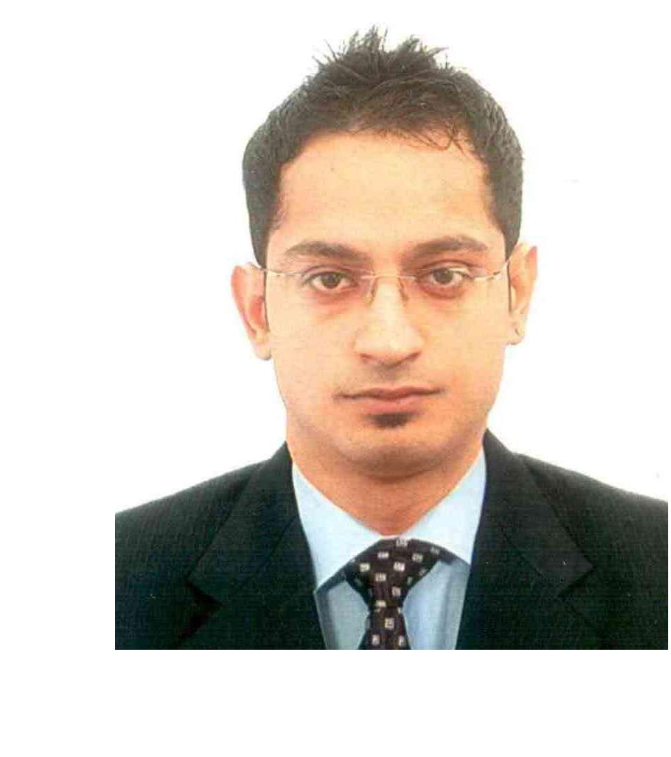
Curriculum vitae

Ashish
Email: ashish.339249@2freemail.com

Career Objective

To associate with progressive organization that gives me scope to update my knowledge and skills according to latest trends and be a part of team that dynamically works towards the growth of organization and gain satisfaction.

Skills

Responsible for other duties as assigned. Excellent communication and writing skills. Excellent ability to work with numbers.

Excellent time management skills.

Ability to handle administrative functions and complete projects.

Computer Skills

Ms-office

Tally ERP – 9.0 Browsing Internet FoxPro

Focus Accounting

Employment Details

Nov 2012 – Oct 2016

Al Fahidi Street,

Worked as an Accountant Cum Salesman in Burdubai (UAE)
L.L.C.

RATTI TRADING L.L.C.

Profile –Accountant Cum Salesman

Prepare, examine, and analyze accounting records, financial statements, and other financial reports to assess accuracy, completeness, and conformance to reporting and procedural standards.

Analyze business operations, trends, costs, revenues, financial commitments, and obligations, to project future revenues and expenses or to provide advice.

Report to management regarding the finances of establishment. Establish tables of accounts, and assign entries to proper accounts.

Develop, maintain, and analyze budgets, preparing periodic reports that compare budgeted costs to actual costs.

Prepare forms and manuals for accounting and bookkeeping personnel, and direct their work activities.

Investigate bankruptcies and other complex financial transactions and prepare reports summarizing the findings.

Sept 2009 - Oct 2012 Dubai, UAE

Worked as an Assistant Accountant in Account and

Administration Department in Florida Textiles L.L.C.

Profile – Assistant Accountant in Account and Administration Department

FLORIDA TEXTILES L.L.C.

Maximize the Export Sale Figure.

Maintain client’s Accounts, delivery order, purchase order, payment follow up. Maintaining stock Purchase and Sales bills.

Update clients with promotions & new offers via emails everyday. Maintain Good Communications with Clients.

Responsible for preparing & analyzing flow of expense & generation of the

voucher & processing it for the final accounting

Initiated & currently managing the month end close process for the payment Ensuring final closing of account payment & receivable.

Preparation of debit /credit notes.

Responding to incoming email & phone enquiries.

Education / Qualifications

Graduate in Commerce.

From- MDS university (MaharishiDayanandSaraswati).

RBSE 12TH–
Passed Senior Secondary Examination Commerce Ajmer, Rajasthan,
& Accounts India

ST. Thomas Sr. Sec. School

Graduated: 2006

Grade: 66%

RBSE 10TH –
Passed Secondary Examination

ST. Thomas Sr. Sec. School

Graduated: 2004

Grade: 51%

Languages

Name Proficiency

English Fluent

Hindi Fluent

Arabic Intermediate

Immigration / Work Status

- United Arab Emirates – Tourist Visa Holder
- Can Join Immediately.

- Having UAE driving License.

Personal Profile

Date of Birth - 27th February 1990.
Nationality- Indian

Religion- Hindu (Sindhi)

Marital status– Unmarried

Passport Number-

Ashish

