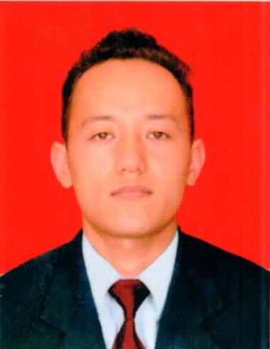
Personal details

BIKASH
Email: bikash.340661@2freemail.com

Date of Barth: 17/06/1991
Nationality: Nepalese
Address: Burdubai

Objective:
To provide excellence service to guest so that they feel special and welcomed to attend a better room and hotel area. And I am looking forward for Room Boy.
Housekeeping Room Attendance
- 3 years of experience in cleaning & Housekeeping area
- Enthusiastic to work in the hospality industry
- Committed to provide outstanding guest service
- Able to work in afternoon, Nights, Weekends & holidays.
- A fun, optimistic attitude with a good sense of humor
- Clean & professional appearance
- Demonstrate team player who always ensure smooth hotel operation
- Able to follow instructions of daily project & procedures.

Personal Experience
Housekeeping Attendant Club Himalaya Resort, Nagarkot, Nepal Dec-2013 to Dec 2016
- Respond quickly to requests from guests and other departments
- Dust, buff, and get rid of marks from walls and Furnishings
- Empty trash, dirty linen, and room service items
- Ensure that all appliances are present in the room and in functioning order
- Straighten desk item, furnishings, and appliances
- Vacuum carpets and carry out floor care duties
- Restore guest amenities and supplies in room
- Replace unclean linens and terry with clean items
- To clean the whole entire rooms of the floor which is VD, VC, and VD etc
- In additional I have six month of waiter Training in Club Himalaya Resort.

Education
Currently doing High Schooling from Shree Tapeshwor Higher Secondary School, Nepal

Special Skills
- Concise, clear verbal and written communication skills
- Excellent customer service skills
- Able to read and interpret documents
- Basic knowledge of computer and MS office
- Good knowledge of chemicals so cold Diversey (R1,R2,R3,R4,R5,R6,R7)

Personal information
Can speak and write Nepali, Hindi, and English Fluently.

