CHRISTAKALA
CHRISTAKALA.344510@2freemail.com
Professional Profile
SENIOR EXECUTIVE ASSISTANT / OFFICE MANAGEMENT PROFESSIONAL PROFILE

Proven experience of effective supervision, motivation and support of staff; skilled in providing or overseeing successful administrative support and office systems within a complex organization; skilled in handling administration related activities; capable of handling a wide variety of tasks including supervising travel desk activities, reporting status, handling customer queries and administration

~Experienced in tracking of all aspects of projects so as to ensure budgetary and corporate compliance, filing and following up; liaising with travels and logistics, International Leadership Team and franchisee visits

~Knows the Business: Possess demonstrative capability of transforming business by going beyond boundaries of People capital support
~Strategic Contribution: Can direct operations in new areas and motivate people to perform beyond their normal past demonstrated skills
~Skilful Execution: Makes things happen against the odds in a collaborative way

Versatile, innovative, and trustworthy management professional able to see “the big picture” while staying on top of all details; excellent interpersonal, communication & organizational skills with proven abilities in customer management and business communication

Professional Summary

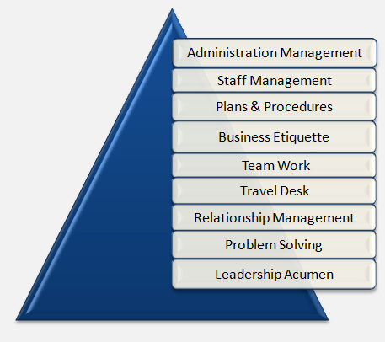
- Profile: Accomplished and seasoned professional with a strong aptitude to understand, set up and lead office operations to set business objectives; breadth of experience across all aspects of strategizing, directing and executing large scale office operations
- Expertise: Dexterous in supervising entire administrative operations of the organization; providing full and comprehensive services to all customers, controlling team performances, planning staff training and development leading to maximizing productivity and performing many other activities as assigned by top management
- Career Contour: Last associated with Pizza Hut, Dubai as Office Manager. Trusted service record with Yum! Restaurants as Senior Executive Assistant to Managing Director; Air Charter International, Jebel Ali as Assistant Manager – Administration and worked with many other well-known organizations
- Experience: Proven skills in planning & organizing events including the Market Planning Meeting, annual Franchise Conventions, Franchisee of Year Awards Celebrations, functional meetings. Managing all aspects of international & domestic travels; coordinated visits of worldwide partners, clients and team
- Extra-Curricular Activities: Delivered full support in staging the annual charity event ‘Battle of the Bands cum Fun Fair’ for the UN World Food Program (in collaboration with Dubai International Academy) over 3 consecutive years
- Business & Interpersonal Traits: Focused approach to work and comfortable in liaising with people at any level of business; Capable of leading large, cross-functional and multi-disciplinary teams while achieving goals and objectives

Professional Skills, Highlights & Key Role
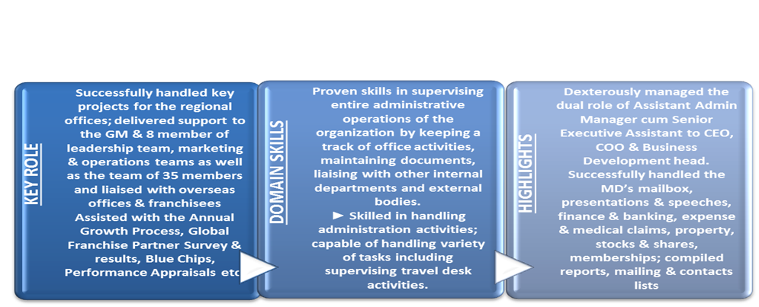

Foundational Strength

Executive Assistance to C-Level Office Operations Management Administration Strategic Planning Evaluation & Selection of Medical Insurance Scheme Budgeting International and Domestic Travels Operational Transformations Cost Saving Initiatives Customer Management Relationship Management Multi-Disciplinary People Management Quality Services Team Management Leadership Acumen Process Improvements Issue Resolution Negotiation Time Management

Specific strengths include:
- Exceptional work ethics, routinely use available time to solve organizational problems while working without direct supervision and completing all assignments and provides a wide range of high-level support services to diverse departments
- Track record of achieving professional success in every endeavour; an enterprising individual with excellent problem-solving skills in fast-paced environment while maintaining a high degree of accuracy
- Known for utilizing time effectively and efficiently – Can concentrate efforts on important priorities along with attending to a broader range of activities as a result of organizing time; ability to orchestrate multiple activities to accomplish goals

Work Experience

January 2014 - December 2016 with Pizza Hut, Dubai as Senior Executive Assistant / Office Manager
Successfully handled key projects for the regional offices; delivered support to the GM & 8 member of leadership team, marketing & operations teams as well as the team of 35 members and liaised with overseas offices & franchisees. Assisted with the Annual Growth Process, Global Franchise Partner Survey and results, Blue Chips, Performance Appraisals, People Planning Reviews, interviews, mentoring calls, telecoms, video conferences, presentations and reports, Calendars, Agendas, contact lists

Key Deliverables
- Strategic Planning: Developing and leading development of plan which delivers key target objective; managing department, staff, protocols, disciplines and processes. Ensuring all operations adhere to, and complies with corporate governance, statutory, standards and others requirements
- Office Operations Management: Accountable for planning and organizing events including the Market Planning Meeting, annual Franchise Conventions, Franchisee of Year Awards Celebrations, Functional Meetings. Administered and tracked all aspects of projects so as to ensure budgetary and corporate compliance, filing and following up
- Policies Alignment: Maintaining continuous alignment of office operations scope with strategic business objectives, and providing recommendations to modify and enhance effectiveness toward business result or strategic intent
- Quality Services: Managing the implementation of best practices in all relevant business functions ensuring fulfilment of business requirements while delivering quality service in line with company vision, mission and strategy
- Process Enhancements: Identifying, initiating and implementing enhancements in existing processes in order that it improves the units’ efficiency as well as effectiveness, thus reducing costs by improving performances & providing superior level of service to principals
- Liaison & Coordination: Coordinating with various departments and preparing reports as well as documents in order to support in decision making process while coordinating with senior authorities; developing and sustaining successful internal and external relationships. Coordinated Travels and logistics, International Leadership Team and franchisee visits
- Leadership Acumen: Providing leadership and vision to organization by assisting Top Management in the development of long range and annual plans, and with evaluation and reporting of progress on plans
- Team Building: Guiding and mentoring team members in accomplishment of objectives; improving their performance through counselling, skills enhancement. Creating and sustaining a dynamic environment that fosters development opportunities and motivates high performance amongst team members

August 2008 - January 2014 with Yum! Restaurants (franchisors- Pizza Hut, KFC, Taco Bell), Dubai as Senior Executive Assistant to the Managing Director

Key Deliverables:
- Successfully handled the MD’s mailbox, presentations & speeches, finance & banking, expense & medical claims, property, stocks & shares, memberships; compiled reports, mailing & contacts lists
- Monitored and tracked execution of annual planning and budgeting, encouraging the use of monitoring activities to foster improvement in program quality
- Built and continued strong working relationships with customers, high-profile clients and business partners. Helped to build a platform of trust by dealing with customers and resolving issues

March 2008 - August 2008 with Air Charter International, Jebel Ali as Assistant Manager – Administration

Key Deliverables:
- Dexterously managed the dual role of Assistant Admin Manager cum Senior Executive Assistant to CEO, COO & Business Development head.
- Coordinated with the Jebel Ali Free Zone Authorities (JAFZA) for immigration and visa formalities, trade license renewals and administrative issues and put processes in place
- Successfully handled the evaluation and selection of the Medical Insurance scheme
Previous Engagements

July 2002 – February 2008 with Yum! Restaurants, Dubai
Succession Path:
Executive Assistant ► Managing Director

February 2002 - June 2002 with Insyst Technologies (MEA) Ltd, Dubai
Succession Path:
Executive Secretary ► CEO

January 1993 - November 2001 with Arthur Andersen, Mumbai, India
Succession Path:
Executive Secretary ► Country Managing Partner
Delivered support to CMP and Leadership Team & team of 50; as Group Secretary liaised with division heads, secretaries & overseas offices. Successfully managed all aspects of international and domestic travels; coordinated visits of worldwide partners, clients and team

Education & Credentials

1992 Bachelor of Commerce from Bombay University

Professional Courses:
- Executive Secretarial Course, Clare’s Secretarial School, Mumbai, India
- Shorthand course, Nadia’s Training Institute, Dubai, UAE

IT Skills: MS Word, MS Power Point, MS Excel, MS Outlook, Outlook 2016, Lotus Notes, iCloud & Dropbox

Personal Details

Date of Birth: 1st December, 1970
Linguistic Abilities: English

