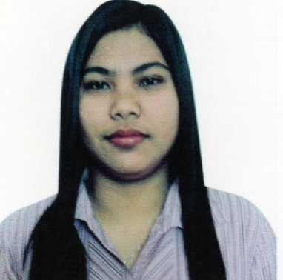
JOCELYN
JOCELYN.344673@2freemail.com
Al Quoz Dubai, UAE

Objective:To apply to any position that is suitable to my knowledge and skills can be develop by a progressive and a high growth company with extensive advancement opportunities.

Capabilities and Competencies:

- Can concentrate on the work with sincerity and dedication.
- Creative individual with assurance to take on task& can deliver efficient results.
- Aggressive achiever able to work with initiative.
- Self motivated, hardworking, goal oriented, social and flexible.
- Communication skills oral and written.
- Ability to work well under pressure
- Quick learner, keen to learn and improve skills

Working Experience:

Office Assistant/Secretary
December 2015 to February 2017
Al Taawon Consulting Engineers Office
Al Rigga, Dubai UAE.

Job Description and Responsibilities:

- Maintains office operations by receiving and distributing communications.
- Fielding telephone calls, receiving and directing visitors, word processing, creating spreadsheets and presentations, filing, and faxing.
- Reporting to administrative or office manager
- Maintains as accurate and efficient filing system for administrative files, clinical files, personnel files, and general non-clinical forms. Ensures the security and confidentiality of file contents.
- Completes requests by greeting customers, in person or on the telephone; answering or referring inquiries.

Additional Qualifications:
- Proficient in Microsoft Office
- Customer Service Oriented

Cashier/ Sales Executive
April 2014 – October 2014
SM Mart Inc.
Makati Ayala Center Philippines

Job Description and Responsibilities:

- Count money in cash drawers at the beginning of shifts to ensure that amounts are correct and that there is adequate change.
- Scans items, requests price checks, honors appropriate coupons, collects payment and gives change as appropriate.
- Issue receipts, credits, or change due to customers.
- Assist customers by providing information and resolving their complaints.
- Responsible for counting contents of cash register drawer at the end of each shift. May bag items or perform other duties as needed.
- Process credit or debit card transactions and validate checks.
- Calculate total payments received during a time period, and reconcile this with total sales.
- Answer customers' questions, and provide information on procedures or policies.
- Greet customers entering establishments.
- Sell or promote products to the customer.

Personal Details:

Date of Birth : 29TH September 1993
Place of Birth : Isabela, Philippines
Civil Status : Single
Nationality : Filipino
Religion : Roman Catholic
Languages known : English &Tagalog
Educational Qualification : Bachelor of Science inInformation Technology
Visa Status : End Contract

