CURRICULUM VITAE
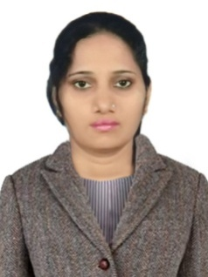

Niteshree
C/o-Contact No. # +971505891826
– niteshree.345102@2freemail.com
Work Experience – 8 years

Career Objective

Pursue career in a progressive organization offering a conductive work environment & opportunity for permanent growth that welcomes a dynamic result oriented professional.

Professional Experience

- Mayfair Palm Beach Resort ,Gopalpur (India): Asst. Manager: Sales ( March 2015- Till Date)

- Mayfair Palm Beach Resort Gopalpur (India): Senior Executive: Sales (January 2012- March 2015)

- Hotel Presidency, Bhubaneswar (India): 3* Hotel: Executive: Sales (January 2009- December 2011)

Job description:

- To assist the Resort Manager in improving the sales of the Resort.
- To selling guestrooms, meeting space and other hotel services to corporates and individuals.
- Conducting site inspections with customers as well as soliciting and generating new business.
- To ensure that all guests’ wishes are met so far as is reasonably possible.
- Maintaining well organized documentation and reports.
- To liaise with other Departments.
- Responsible for sending proposals, negotiating contracts, pricing, credit terms, warranties and delivery date.
- To make sure that Company Policy and the Vision are followed at all times.
- To verify feedback obtained from guests and to use this to improve service and to pass on such to the resort manager.

Academic & Technical Qualification:

- Bachelor in Arts from Goa University in 2008
- Intermediate from Goa Board of Secondary and higher secondary education, Alto-Betim, Goa, 2005.
- High School from Goa Board of Secondary and higher secondary education, Alto-Betim, Goa, 2003
- Diploma in computer applications.

Personal Details

- Date Of Birth --- 2th November 1985
- Language Known --- English, Hindi, Konkani, Oriya
- Marital Status --- Unmarried
- Passport No. --- G7238462
- Nationality --- Indian
- Strength --- Good communication & interpersonal skills,Positive attitude, goal oriented, self- motivated, problem solving abilities, leadership, Qualities, team facilitator, quick learner.
- Interest & Hobbies --- Doing social work, Listening Music, Travelling

Declaration

I do hereby certify that all the information furnished above is true to the best of my knowledge. Supporting documents will be produced as and when required

