VINOD
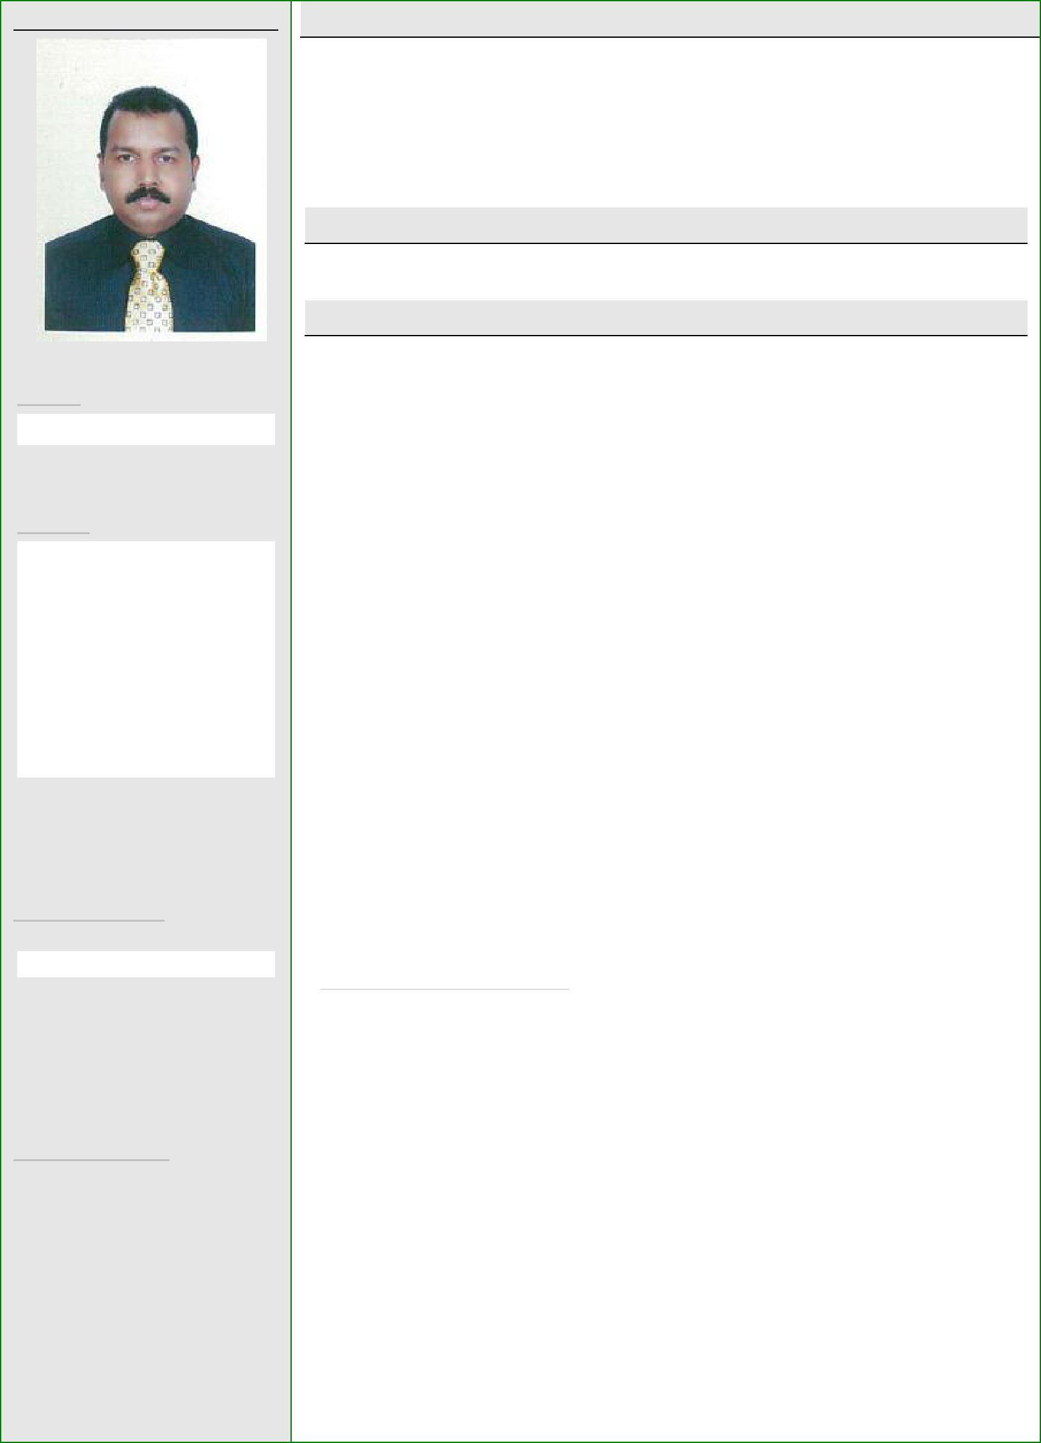

PERSONAL PROFILE:

Email:

Vinod.345396@2freemail.com

 | Personal Data:
 | Date of Birth |  |  | : 27/Aug/1969
 | Gender | : |  |  | Male
 | Marital Status | : |  |  | Married
 | Nationality | : |  |  | Indian

Key Knowledge:

- Procurement Procedures

- Import Procedures and documentation

- Oracle Procurement module

Computer Skills:

- Oracle
- Tally
- Microsoft Office
- Internet
- Email

CARRIER OBJECTIVE:

Intend to build a career with leading corporate of hi-tech environment with committed and dedicated people, which will help to explore myself fully and realize my potential. I can utilize my skills, where my knowledge can be put into practice to create / ensure a co-operative, organized & systematic working environment for benefiting the company and its personnel.

EDUCATIONAL ATTAINMENT:

- Higher Secondary

EXPERIENCE SUMMARY:

 | Position |  |  | Company | Country | Period
 | Purchase |  | Sea Eagles Shipping LLC |  | Sharjah | Feb 2016 to
 | Assistant |  |  |  |  | till date
 | Purchase |  | Rawabi Specialized Enclosures |  | Saudi | Jan 2010 to
 | Assistant |  |  |  | Arabia | Oct 2015
 | Import |  | Rawabi Alamin Distribution Company |  | Saudi | Mar 2006 to
 |  |  |  |  | Arabia
 | Executive |  | Ltd. |  |  | Dec 2009
 | Import |  | Ali Rashid Al Amind Company |  | Bahrain | Dec 2005 to
 | Executive |  |  |  |  | Feb 2006
 | Executive |  | R K SWAMY BBDO Advt. Company |  | Mumbai | 1999 to
 | Secretary |  |  |  |  | 2005
 | Secretary |  | Percept Advertising Company |  | Mumbai | 1993 to
 |  |  |  |  |  | 1998
PROFESSIONAL EXPERIENCE:
1. Date |  |  | : | February 2016 – Till Date
 | Designation : |  |  | Purchase Assistant
 | Company |  | :Sea Eagle Shipping LLC

DUTIES & RESPONSIBILITIES:

- Purchasing all items related to ship maintenance as per the request from technical dept.

- Arrange all publications and booklets required for vessel
- Arrange safety items for crews
- Purchase all type of consumables as and when required for the vessel
- Purchase all items related to Office, Garage and staff accommodation
- Prepare PO and send to supplier
- Follow-up for delivery

2. Date : January 2010 – October 2015
Designation : Purchase Assistant

Company : Rawabi Specialized Enclosures – Saudi Arabia
(Rawabi Holding Group)

Key Skills & Competencies:

- Expert in Purchasing process and procedures

- Experience in import procedures and documentation

- Strong decision-making skills and the ability to prioritize and plan effectively.

- Ability to work under pressure

- Excellent negotiation and communication skills

Languages Known:

- English

- Hindi
- Malayalam
- Arabic

Passport Details:

Date of issue: 09/08/2015
Date of expiry: 08/08/2025
Place of Issue: Riyadh KSA

DUTIES & RESPONSIBILITIES:

  - Find out potential suppliers and provide questionnaire to find out their credibility and include them in our supplier list if it is as per our company standard requirement

  - Do the assessment and evaluation of existing suppliers on quarterly basis based on their performance

  - Updating of approved supplier list on quarterly basis

  - Prepare Request for quotation and make sure all of them are as per bill of materials / Purchase Requests.

  - Prepare comparison sheet and negotiating the price
  - Prepare PO in oracle system and send to supplier
  - Preparing LC application

  - Follow-up for delivery and inform the schedule to warehouse and production

  - Cancellation of order, if materials are not as per PO and return the same to supplier or request for replacement.

  - Make sure all supporting documents related to each PO is submitted to finance dept. on time to process the payment
- Follow-up with finance dept. supplier’s payment is releasing on due date
- Prepare material status report for each project for management review
- Prepare monthly report

- Follow-up with overseas supplier to make sure the shipment is as per schedule

- Inform to the supplier about necessary documents required for custom clearance and make sure documents are arriving before the shipment arrival

- Verify all the documents required custom clearance and send to clearing agent in advance

- Co-ordinate with clearing agent for overseas shipment
- Prepare / submit necessary documents required for custom clearance.
- Follow-up with finance dept. for advance payment for custom duty

- Follow-up with clearing agent to clear the shipment on timely manner without any demurrage

3. Date : March 2006 – December 2009
Designation : Import Executive & Secretary to GM
Company : Rawabi Al-Amin Distribution Co. Ltd. – Saudi Arabia
(Rawabi Holding Group - FMCG Division)

DUTIES & RESPONSIBILITIES:

IMPORT EXECUTIVE

- Placing orders to overseas suppliers
- Preparing LC application
- Co-ordinate with shipping company for freight charges

- Make sure supplier can provide all required document as per SASO regulation

- Verify the required documents for the shipment and inform to the supplier in advance

- Co-ordinate with clearing agent for custom clearance

- Submit the required documents to clearing agent before the arrival of shipment

- Co-ordinate with insurance company if any damages in packing or defrost etc. Import documentation

- Inform to supplier if any damage/shortage of material immediate after receiving them in our warehouse.

Languages Known:

- English
- Hindi
- Malayalam
- Arabic

Passport Details:

Date of issue: 09/08/2015
Date of expiry: 08/08/2025

Place of Issue: Riyadh KSA

SECRETARY

- All office related work to GM office
- Fix up meeting with client
- Follow-up with the client
- Preparing letter / minutes of the meeting
- Maintaining filing systems

4. Date : December 2005 – March 2006
Designation : Import Executive & Secretary to GM
Company : Ali Rashid Al-Amin Company - Bahrain

DUTIES & RESPONSIBILITIES:

- I was under training for Import procedures and documentation.

5. Date : 1999 – November 2005
Designation : Executive Secretary to VP
Company : R K SWAMY BBDO Advertising Pvt. Ltd - Mumbai

DUTIES & RESPONSIBILITIES

- Secretarial assistance to Vice President
- Fix up meeting with client
- Preparing power point presentation
- Preparing letter
- Co-ordinate with visual & print media for client PR activities
- Follow-up with client
- Maintaining filing systems

5. Date : 1993 – 1998
Designation : Secretary
Company : Percept Advertising Pvt. Ltd - Mumbai

DUTIES & RESPONSIBILITIES:

- Secretarial assistance to the client servicing department
- Taking dictation and transcribing letter
- Follow-up with media and publication

- Follow-up with client
- Preparing power point presentation
- Maintaining filing systems

DECLARATION:

I, hereby declare that all the information mentioned above is true to the best of my knowledge

