Curriculum Vitae  GOPU  GOPU.347566@2freemail.com  \ | 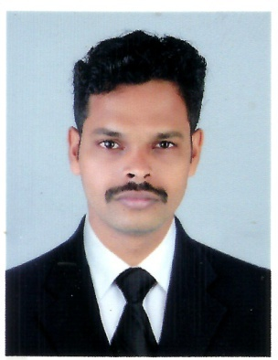

OBJECTIVE

To engage in a career that will allow for progress in terms of expertise, socio-economic development, and innovation through exposure to new ideas for professional growth, as well as growth of the company.

CAREER SUMMARY

- Recently worked with Sreepadmam Fire & Life Safety Engineers,Thrissur, Kerala, India
- 2 years and 10 monthsof experiencein Accounting.

WORK HISTORY

From 18th April 2014 to 22th October 2014,

As AccountantInBenz Auto Spares, Bangalore, Karnataka, India

Reporting toManaging Partner.

From27thOctober 2014 to 17th February 2017,

AsJunior Accounts ManagerInSreepadmam Fire & Life Safety Engineers,Thrissur, Kerala, India

Reporting toGeneral Manager.

JOB PROFILE:

- Preparing, maintaining, analyzing, verifying, and reconciling financial transactions, financial statements, records, and reports and processing year end accounts.
- Preparing weekly confidential project reports for presentation to management.

- Responsible for sales tax return ,works contract return, and annual return of company
- Reviewing the company’s financial systems.
- Preparation of pay roll, purchase orders etc.
- Preparing monthly reconciliations of balance sheet accounts.
- Prepared works contract and sales tax returns for audit.
- Preparing monthly reports for senior managers that include business Project status and Performance Indicators.

EDUCATION

- Master of Business Administration(MBA- Finance)from Universityof Mahatma Gandhi,Kottayam,Kerala,India. Passed inApril 2014 with 60% marks
- Graduation inBachelor of Commerce from University of Calicut,Kerala, India. Passed in April 2012 with 69% marks
- Board of Higher Secondary Examination,Kerala, India. Passed in March 2009 with 83% marks
- Matriculation - Secondary SchoolLeaving Certificate Examination, General Education Department Government of Kerala, India.Passed in March 2007 with 90% marks

COMPUTER SKILLS

- Tally
- Peachtree
- Daceasy
- MS-Office
- Windows
- Other basics of computer

PERSONAL PROFILE

- Date of birth : 02nd October1991
- Nationality : Indian

