CURRICULUM VITAE
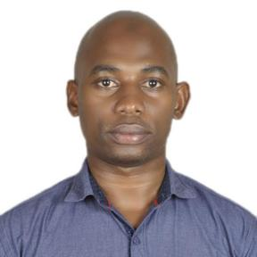
Personal Information:
SSALI
Nationality: Ugandan
Marital Status: Single
Email: ssali.348624@2freemai.com
Sex:Male
Visa Status:Visit Visa
Notice period:Immediately

Personal Profile
I am passionately committed to producing good results, I can achieve targets under minimal supervision,good at complying to rules and regulations, sensitizing and working in teams, self driven, self motivated, result oriented with good interpersonal, oral and written communication skills.
Career Objective
Seeking for opportunities and challenges to develop and advance my professional career through meeting different people hence achieving my personal goals and objectives.
Education Background

University: Makerere University
Bachelor of Entrepreneurship and Small Scale Business
Management
High school: Kawempe Muslim Secondary School
Uganda Advanced Certificate of Education (U.A.C.E)

Working Experience

Cashier;5yrs
Tick Hotel,Kampala-Uganda
Duties include;
- Checking daily cash accounts
- Guiding and solving queries of customer
- Providing training and assistance to new joined cashier
- Greet the customers entering into hotel
- Handling all the cash transactions
- Receive payment by cash, cheques, credit card etc
- Maintaining monthly, weekly and daily report of transactions
- Any other duties assigned
Customer service Receptionist;2years
Modern Operators(u) ltd,Kampala-Uganda
Duties include;

- Welcoming visitors by greeting them in person or on the telephone.
- Answering or referring inquiries.
- Giving instructions.
- Maintaining security by following procedures.
- Monitoring logbooks.
- Issuing visitors badges.

Computer skills

Computer applications especially on Microsoft Word,Excel and power point.

Languages:

Communication skills, both oral and written in English. Being new introduced to the U.A.E community; I understand the importance of effective communication to build strong relationships amongst all cultures.
References:
Available upon request

