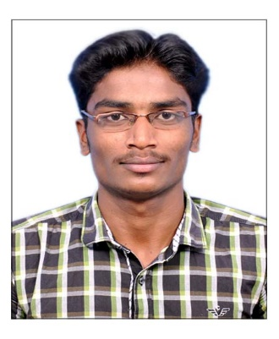
SUKUMAR
SUKUMAR.348672@2freemail.com

OBJECTIVE:
Ability to work in the challenging environmental to expose my skills for the successes of your esteemed organization and can work in collaborative group in professional and ethical fashion.
EDUCATIONAL QUALIFICATIONS:
Course | Institution | Board/University | Percentage | Year of passing
B.E Mechanical | Shivani Engineering College, Trichy. | Anna university- Chennai | 66% | 2014
HSC | Punitha Arockiya Annai Hr.Sec.School, Punalvasal. | State board | 67% | 2010
10th | Punitha Arockiya Annai Hr.Sec.School, Punalvasal. | State board | 61% | 2008

EXPERIENCE IN SOFTWARES:
      - AUTOCAD
      - SAP
WORK EXPERIENCE :
COMPANY : BHARAT ELECTRONICS Ltd., Chennai,India
PRESENT DESIGNATION : Contract Engineer On Contract Basis
DEPARTMENT : Material Management (purchase – procurement-stores)
PERIOD : 2nd July2014 to 31st Jan 2017(Two and Half years)

During My Working Period, I Was Trained In Material Management Activities Like:
  - Accessing SAP- Material Management (MM) Module in following areas.
  - Ability to understand purchasing and procurement methods & procedures.
  - Identifying suppliers for Approved products as per Manufacturer (MPN) List.
  - Review requisitions and identify source of supply.
  - Select contract / supplier to fill requisition in accordance with approved purchasing strategies.
  - Preparing price comparison statement and Purchase Orders.
  - Manage transactional interaction with suppliers, work with buyer group and supplier to resolve supplier claims, invoice discrepancies, damaged/return goods & ship date issues.
  - Maintain the vendor master records/update/new vendor setup.
  - Preparation of Purchase proposal for Management Approval for Purchase Orders.
  - Preparation of Document & Reports in Microsoft Word & Excel.
  - Maintaining product / Item-wise approved Vendor List.
  - Working Experience in Online Procurement through SRM (Supplier Relationship Management through the Web Portal established by BEL).
  - Preparation of Purchase related documents and Proposal through FLM (File Life Cycle Management).
  - Preparations of ‘Consignment Receipts Report (CRR) & Goods Receipt (GR) for inland items. Receipts of Inland &Foreign Materials.
  - Preparation of ‘Logistics Invoice Verifications’ (LIV) &’Goods Receipt’ (GR) For Foreign item. Forwarding all invoices with respect Document to Finance for payment to vendor.
  - CENVAT Updating in SAP Modules as per percentage availed in the Invoice Copy For inland &foreign items.
ACADEMIC PROJECT:
Design & analysis of Shell & Tube Heat Exchanger Using HTRI, at Bharat Heavy Ele. Ltd,Trichy.
AREA OF INTREST
  - MATERIAL MANAGEMENT
  - PRODUCTION
  - QUALITY

ACHIEVEMENT
  - Attend Workshop about IC Engine at CIT, Coimbatore.
  - Attend Workshop about NDT at CIT, Coimbatore.

PERSONAL STRENGTHS:
Leadership.
Quick learner.
Smart worker.
PERSONAL DETAILS:
DATE OF BIRTH : 26.05.93
MOTHER TONGUE : TAMIL
MARITAL STATUS : SINGLE
LANGUAGES KNOWN : ENGLISH,TAMIL
HOBBIES : PLAYING CHESS & CARROM, WATCHING TV.
VISA TYPE : VISIT VISA

DECLARATION:
I hereby declare that the above furnished details are true to the best of my knowledge.

