PERSONAL INFORMATION | Emir  Emir.348823@2freemail.com
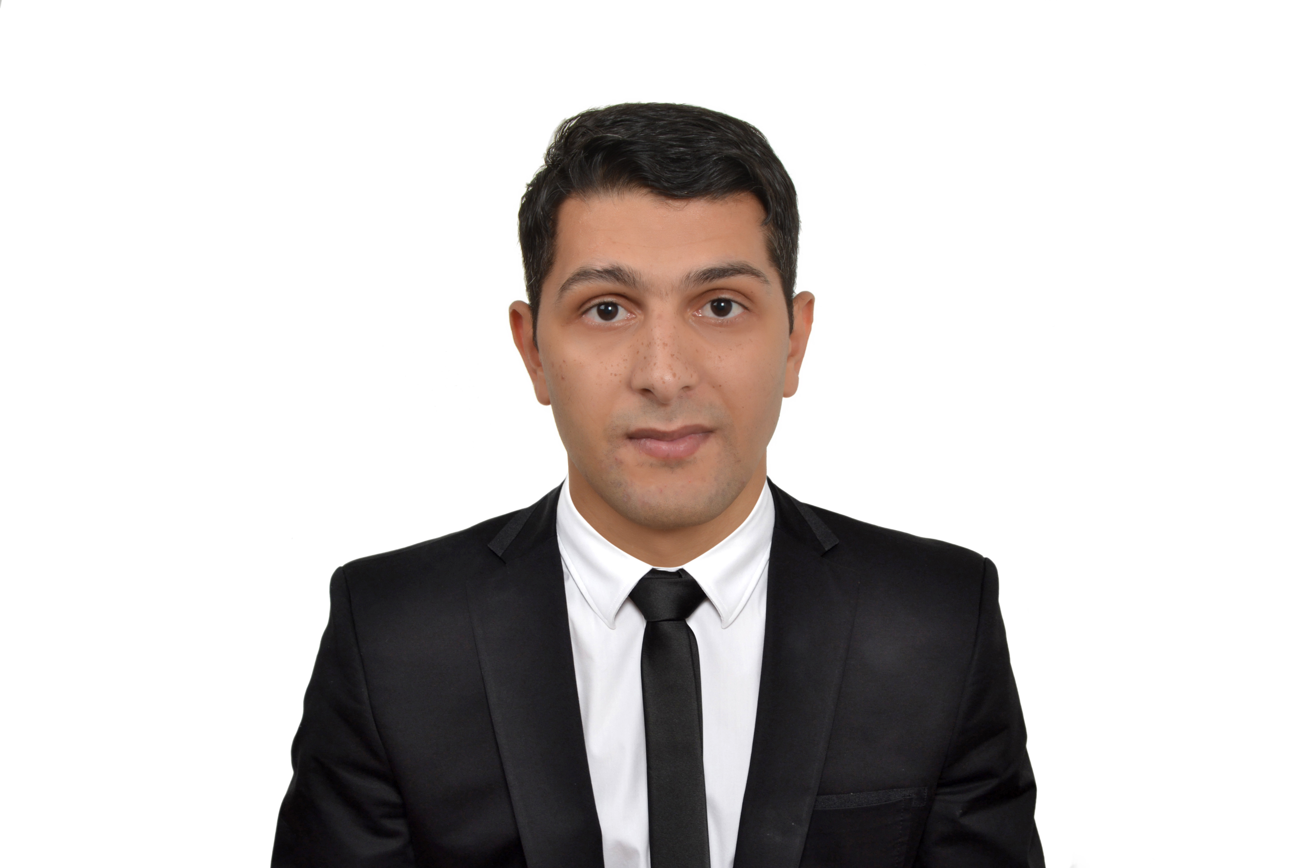
Looking primarily for Management or Supervisory positions within Retail/FMCG, Luxury Brands, Fashion or F&B/Hospitality industry like Sales Manager, Business Development Manager, Marketing/Sales Supervisor or Associate, Warehouse Manager; also Project Administrator, IT Engineer and similar, but not limited to other available Executive or Managerial Sales roles. I am currently based in UAE and immediately available for good job opportunity. I used to work and specialize mostly in fashion, retail & F&B types of industries, but I am open to expand my knowledge in other sectors focused on sales as well, such as furniture/design etc.

I am an ambitious, determined and self-motivated Senior Sales Associate with 6+ years of record including GCC experience from UAE and SEE experience from Macedonia.

Apart from crafting effective sales strategies, leading large teams, conducting marketing operations and improving distribution networks - resulting in more contracts, increased sales, business expansion and organizational growth, my aim is to develop further my managerial skills in the Gulf Arabic countries thus increasing and completing my career with upgraded knowledge and professional growth. This area is well-known for advanced luxury brands industry with a lot of opportunities to attract VIP types of buyers. I would like to be directly exposed to clients from different social and cultural backgrounds in order to enrich my multicultural experience and develop further sales skills. I am looking for long-term collaboration and possibility to progress gradually to some more responsible, senior sales position within a right company. Rich blend of business, management, analytical and leadership skills backed up with 6+ years of Sales/Warehouse and Customer Service experience, having passed positions from Sales Executive to Warehouse Manager and Senior Sales Associate (current level). My real passion are Business Development, Sales & Marketing of luxury products, Key Account Management across diverse industries in a global set-up. My mission is helping clients/partners identify their needs regarding company's products and services, always exceeding their current expectations.

I am also proficient in the following skills:

- Sales skills: Product Knowledge, Account Management, Bidding, Negotiation, Proposals, Persuasiveness, Cold Calling, Contracting, Closing Deals, Follow-Up, Client Retention, Customer Satisfaction;
- Business skills: Business Analysis, Warehouse Management, Purchase Management, Reading/Interpreting Financial Parameters/Reports;
- Organization, planning and execution of different pre and aftersales activities;
- New Business Development, ability to attract new customers and expand to other markets;
- Marketing skills - Market Intelligence, Trading/Import, Promotion;
- Managerial skills and leadership potential – Team Management, Relationship Building;
- Generally enthusiastic team worker, but also able to work independently or with minimum supervision;
- Excellent oral and written communication skills, talent for negotiation and closing deals;
- Proficient computer skills including expertise in using Microsoft Word, Excel, PowerPoint, Photoshop, as well as internet navigating;
- Strong problem-solving, ability to prioritize and pace work;
- Outstanding interpersonal skills, knowledge of cultural differences;
- Multitasking, effective and efficient time management;
- Demonstrated administrative support experience.

WORK EXPERIENCE APPAREL COMPANY

Senior sales associate February 2016 – February 2017

(Apparel Group is a global fashion and lifestyle retail conglomerate with its strong presence in GCC market & worldwide, including 1530+ stores, employing 12,000 multicultural staff and offering leading names in Fashion, Footwear & Lifestyle such as Tommy Hilfiger, Aldo, Nine West, etc.)

- In charge of complete sales organization for two huge fashion brands: Turkish Waikiki and German New Yorker;
- Provoding all the relevant information to the shop visitors and presenting offers directly
- Setting up, monitoring and then tracking sales parameters;
- Maintaining and developing relationships with existing customers in person and via telephone calls and emails;
- Cold calling to arrange meetings with potential customers to prospect for new business;
- Acting as a contact between a company and its existing and potential markets; negotiating the terms of an agreement and closing sales;
- Negotiating on price, costs, delivery and specifications with buyers and managers;
- Administrative and other tasks upon requests.

Super Market “PRINCE”, Skopje, Macedonia

Warehouse Manager July 2012 – June 2015

- In charge of smooth operations of Warehouse department in a huge retail/grocery shop;
- Receiving, warehousing, and distribution operations by initiating, coordinating, and enforcing program, operational, and personnel policies and procedures in and around warehouse;
- Safeguards warehouse operations and contents by establishing and monitoring security procedures and protocol;
- Making departmental roaster plans, educating staff how to enhance productivity and deliver extraordinary service, resolving possible conflicts between them;
- In charge of stocks monitoring and liasing with suppliers;
- Undertaking responsibility in crisis management situations, implementing necessary measures in order to remove abnormalities/deformities;
- Achieving financial objectives by preparing an annual budget; scheduling expenditures; analyzing variances; initiating corrective actions.

- URBAN Coffee,SKOPJE,MACEDONIA

F&B Sales Executive/Host January 2011 - June 2012

• Welcoming customers arriving at the outlet, allocating tables, presenting menus and taking orders;
• Direct sales of coffee products, presenting offers in a casual & pleasant atmosphere and explaining benefits of consuming special types
of coffees
• Answering telephone calls and providing information upon request;
• Preparing transactions and managing payments;
• Performing market research and creating new marketing strategies in order to enhance sales;
• Assisting in serving food and beverages upon request.

- NGO SUMNAL,SKOPJE,MACEDONIA

Assistant Project Manager August-2008– august-2010

The program was creating for the ROMA population starting from age 13 to teenager age 18 years old who didn’t have chance to be a part of the environment like another population in the country,
the causes the NGO organisation was created with seaport from American Peace Corpus to help the marginal population to be same like the remaining population in Republic of Macedonia

EDUCATION AND TRAINING
• BA: Faculty for Furniture & Interior Design, affiliated to St. Kiril University of Skopje, Macedonia

• Currently pursuing degree in IT Engineering at ASTI, Dubai (2016- )

PERSONAL SKILLS

Mother tongue(s) | Native: Macedonian
Other language(s) | UNDERSTANDING |  | SPEAKING |  | WRITING
Other language(s) | Listening | Reading | Spoken interaction | Spoken production
 | C1 | C2 | C2 | C2 | C2
 | ENGLISH
 | B2 | C2 | B1 | B1 | A2
 | GERMAN
C2 | C2 | C2 | C2 | C1
SERBO-CROATIAN
B2 | B2 | B2 | B2 | A1
TYRKISH
B1 | B1 | B1 | A2 | A1
SPANISH
A2 | A2 | A1 | A1 | A2
RUSSIAN

Computer/Skills  Activates/interest  Referees | • MS Office (Word, Excel, Access, Power Point, Photoshop, Auto Desk, HTML)  • Solid knowledge about social networking and internet marketing tools (SEO, Google analytics)  Sport (martial arts, swimming, basketball), music, fashion, movies.  Holder of driving license B.  Available upon request
COVER LETTER

Dear HR

Being practical, concise and clear in my business life and career, I will try to explain in short my motivation and reasons that qualify me for this job in the following paragraphs.
First, owing to the fact that GCC region has one of the most rapidly developing world economies and is in constant need of good and experienced Sales Managers and Associates, I consider that my EU & GCC expertise and sales skills would contribute to this market expansion to certain, but significant extent. I am familiar with Arabic culture and buyers’ mentality, having had previous experience from famous fashion retail company in Dubai, UAE. Therefore, as perfect English speaker, currently based in Dubai, I would be able to continue to develop my professional skills and career without any language barrier or “culture shock” problems.
I am looking for long-term collaboration and possibility to join some GCC company I consider a huge brand and excellent place for learning and enhancement of my previous experiences. I want to be a part of the team where employees are treated with respect and considered the company’s best investment. In return, I am ready for hard work and constant learning. I recognized ………………. (name of a company) as a very serious and perspective organization that would help me to achieve my goals and therefore I am looking forward to be invited for a job interview.
Second, I consider myself to be an ideal candidate for this job because:

- I have had extensive (6+ years) work experience in diverse economic environments, having passed through many industries (retail, luxury brands/fashion, F&B/hospitality etc.), and all that provided me with various sales skills (see my CV) and the ability to work with different types of people and nationalities. Moreover, my last position was in well-known GCC & global fashion retail company “Apparel Group”, where as Senior Sales Associate/Manager I had proven track of sales record and managerial excellence (having increased the overall market expansion for two fashion brands and having improved significantly the customer service).
- I have covered positions and tasks from Sales Executive/Assistant to Sales & Warehouse Manager and therefore I am proficient in all the procedures regarding sales & stocking activities. Moreover, my BA degree in Interior Design along with diploma from famous Dubai’s ASTI (IT Engineering) makes me highly competent in any kind of industries to cover different aspects of this job.
- I can enable your company to open to the West/East European market since I used to collaborate with many EU companies throughout my career and also help you reach other GCC markets apart from UAE.
- The values I would bring to your company: hard work and discipline, implementation of new solutions and removing defects, passion for sales and achieving - often surpassing set targets, attention to details, extraordinary customer service. Also, one of my strongest points is company administration, warehousing & financial control, direct product presentation & offer along with strong sense of negotiation that leads to sales agreements and new business development.

