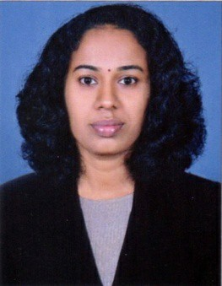

DEVIKA

DEVIKA.348934@2freemail.com
Career Objective
To get expertise working in a social environment adding value to the organization and to become focused and flexible to achieve my goals.
Areas of Expertise
- Able to Work at fast paced and rapidly changing environment
- Developing and motivating teams to do better
- It literate proficient in MS word ,Excel ,power point outlook
- Comfortable in dealing with Senior managers or Executives
- Developing Business relationships through networking
- Willing and capable of learning and adapting quickly
- Understanding a client’s needs ad issues from a business point of view
- Ability to communicate in a clear and effective manner
- Ability to always maintain self-motivation and be consistently pro-active

Skills
Customer Service Team Management Office procedures
Communication Training Phone etiquette

Goals And Responsibilities
ConscientiousandtoworksincerelyEnsure patient satisfaction, fulfillingservice
ObservingcodeofconductTobepatientandpunctual

Professional Experience

Mar 2016 - Dec 2016 BharatRuralHospitalandTrainingCentreErnakulam

Job Description – Pharmacist

Sep 2013 - Nov 2015 AbhiramiMedicalsErnakulam

Job Description – Pharmacist

Feb 2012 - Aug 2012 Govt. hospitalErnakulum

Job Description – PharmacistTrainee

Feb 2007 - Jul 2009 NeethiMedicalStoreErnakulum

Job Description – SalesAssistant

Educational Qualification
- DHA Qualified in October 2016
- D-Pharm (Board examination 2012)
- Plus Two (Board examination 2004)
- SSLC (Govt Of Kerala 2002)

Continuing Education Program Attended
- Lisie Collage of Pharmacy at Ernakulam (11 Jan 2014)
- Govt Medical Collage Kalamassery (28 Aug 2015)

Professional License
Registered Pharmacist, Kerala :

Computing Skills
- Operating Systems –MS Windows
- MS Office
Self-Assessment

Ambitious, Organized, Enthusiastic and a People's Person. Very open minded and optimistic nature that connects with people through team work or one-on-one, Very Good Listener. Able to work with wide variety of individuals and styles.

Languages Known

- English, Hindi,Tamil & Malayalam.

Hobbies

- Music, Reading & Writing

Visa Details

- Visa Type : Visit Visa (Dubai)
- Expiry Date : 9th April 2017

References
Can be provided upon request.

Declaration

I hereby declare that the above specified details are correct to the best of my knowledge and I am confident that I can serve to the best of my effort.

