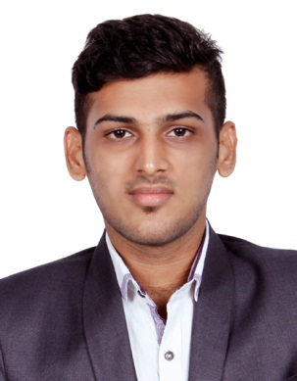
ABDUL
ABDUL.349119@2freemail.com

Profile
An effective communicator possessing excellent presentation & soft skills with experience in marketing, customers services, logical and problem-solving abilities. Specialized in managing customers and their queries and maximizing the sales.
Career Objective
To secure an appropriate position of a renowned organization to contribute towards the growth of the organization based on my expertise and to further enhance my personal capabilities by learning from the new exposure within the structural frame work of the organization
Career History
Gulf Tours and Travels: 2014-2016
Job Responsibility: Sales
- Handling multiple assignments concurrently using excellent time-management
- Major role in business development
- Assist Customers
- Handling International and domestic reservation and ticketing
- Booking reservation for travel, hotels, rental cars
- Carried out marketing-media communication assignments
- Branding And Market research
- Handling passport stamping, visa assistance, certificate attestation
- Efficient sales, self-directed and energetic

Mangloreelectronics : June – October 2016
Role: sales and administrative
    - Handling external and internal communication or management systems
    - Managing clerical or administrative staff
    - Storing and distribution incoming and outgoing post
    - Major roles in sales of electronic products
    - Meeting sales Goals, selling customer needs, sales planning
    - Building Relationships, developing budgets, staffing
ACADEMICS
SSLC | Sudana Residential School, Puttur|Karnataka Board | 2010-2011|
PUC | St. Philomena College, Puttur | Karnataka Board |2012-2013
BBM | St. Philomena College, Puttur | Mangalore University |2013-2016
Technical Skills
Programming: - C, C++
Operating System: - Windows XP, Windows 7, Windows 8
Web Technology: - HTML
MS Office: - Word, Excel, Power point, Outlook
Accounting Software: -Tally ERP 9 (Certified).Peach tree accounting
Core Competencies
- Result oriented
- Strong networking, presentation, multi-tasking and analytical abilities
- Versatile Customer service: win-win attitude, accountability
- Multicultural interaction
- Ambitious, quick learner, hardworking
- IT Skills
- Business to Business approach
- High-level computer literacy: PC, databases, email and internet, word processing and spreadsheets

Achievements
Leaded the university cricket team as a captain which won 1st place in the university
Level and state level crickettournaments.

  - Participate in Inter college fest
  - Prizes in Sports & Games
  - Prizes in Dance and Drama

Personal Details
Date of Birth : 18-Mar-1995
Nationality : Indian
Languages Known : English, Kannada, Malayalam and Hindi
Hobbies : Playing Cricket, Football, Listening music and Driving
Visa Status : Visit visa valid till May 2017
Declaration:
I hereby declare that the above furnished details are accurate to the best of my knowledge and assure you my service to the satisfaction.

