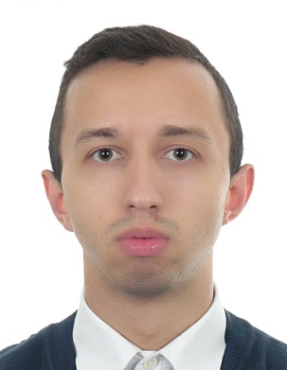
Roman
Roman.349355@2freemail.com

A highly organized detail-oriented professional with experience in customer service and administrative support looking forward to working with motivated people, sharing experience and creating possibilities in a growing company. Open for new ideas. Administrative and customer service experience help me to make a decision in different directions.

WORK EXPERIENCE
Feb 2016 – Feb 2017 Sales associate
New Yorker/LC Waikiki “Apparel Group LLC”
Dubai – UAE
Responsibilities:
- Welcome customers coming to the store, identity their needs, recommend and demonstrate appropriate products.
- Verify stocks daily and place an order for the required quantity of products to ensure maximum stock availability, ensure that the best sellers are available in the department at all time and avoid stock issues.
- Merchandise product in the store shelves to ensure maximum visibility and follow the brands guidelines for the merchandise.
- Update the daily sales report and discuss opportunities to improve sales with the management team.
- Provide advice to clients regarding particular products or services.
- Prepare reports as daily sales, opening/closing store, MTD, YTD, KPI by collecting, analyzing, and summarizing information.
- Teach new staff keeping cash register, product knowledge of department and basic store things.
- Operate cash register.

Dec 2012 - Feb 2016 Administrator of restaurant
Restaurant “Love Story”
Ukraine, Chernivtsi
Responsibilities:
- Coordinate the work and the activities of the staff.
- Perform administrative activities such as scheduling, budgeting, and payroll.
- Estimate the food consumption, placing orders with suppliers, and schedule delivery of fresh food and beverages.
- Maintain a record of all petty cash claims and replenishments & responsible for reconciliation with finance.
- Evaluate health and safety practices against standards
- Doing other tasks when the restaurant becomes busy, including clearing tables, helping in the kitchen, seating guests and working as a cashier.

Mar 2011– Nov 2011 Waiter (part time)
“Cisar” hotel-restaurant complex
Ukraine, Chernivtsi
Responsibilities:
- Present menus to customers and answer questions about menu items, making recommendations upon request.
- Take orders, serve drinks and food.
- Check with customers to ensure that they are enjoying their meals and take action to correct any problems.
- Make up bills and present them to customers.
- Handle money or credit cards.
- Order bar supplies.
- Clean glasses and additional utensils.
- Sanitize ice tanks, coolers, and other bar tools.

EDUCATION

EDUCATION-Institution | Specialization | Year of graduation/City/ Country
Chernivtsi Trade and Economics Institute of the Kyiv National University of Trade and Economics | Accounting and Audit | September 2010 - July 2013 Chernivtsi/Ukraine
Chernivtsi Cooperative Economics and Law College | Bookkeeper | September 2007 - July 2010 Chernivtsi/Ukraine

SKILLS

- Customer service skills
- Communication skill
- Problem solving skills
- Ability to work under pressure
- Adaptability and reliability / maintain office confidentiality
- Analytical skills
- Attention to detail
- Quality performance
- Excellent knowledge of MS Office, MS Excel and related programs

