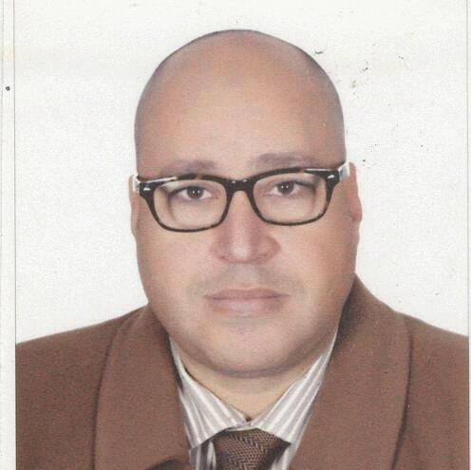
Sherif

Dubai - UAE
Sherif.350118@2freemail.com

Profile | * Managerial experience over than 20 years in Sales, Marketing, Consulting, Training, FMCG, Machinery, Hospitality and real estate for multinational companies such as Pepsi, Coca-Cola, Unilever, British American Tobacco, Grant Thornton and The First Group.  Set the Business Operations & manage resources and achieve the goal as a Leader.
Skills &Projects  Sales & Marketing  Channel management  Business development  Team management | Developing strategies for market penetration for new products as well as increasing the share of the existing products by designing & implementing marketing activities for enhancing Brand Awareness & Visibility. Reviewing & interpreting the competition & market information to fine-tune strategies. Implementing merchandising activities like display / stock arrangement in attractive manner at retailer end to create effective visual impact.  - Project: KPI lead to build warehouse and plant. 3%market share  Identifying and networking with reliable and cost effective channel partners for enhancing market reach and penetration. Demand Forecasting & ensuring cost effective logistics operations across the distribution channel and monitoring availability of requisite goods at the various sales outlets/ channels.  - Project: promotional & awareness for new products  Identifying business opportunities in terms of development of new products on the basis of understanding the customer needs. Drafting competitive plans for generating sales, developing & expanding market share towards the achievement of sale Targets. Maintain Customer relationship.  - Project: Establish CRM to control clients and its revenue (5000 clients)  - Project: cost reduction with third party to eliminate cost around 17%  Incorporating bonded teamwork and managing healthy environment. Leading, training & monitoring the performance of team members to ensure efficiency in sales operations and meeting of individual & group targets.  - Project: Training& Information system by using OASIS.
Education | *High management diploma in Business Administration (SAMS)  *High management diploma in Information Systems (SAMS)  *Bachelor of Arts / Cairo University 1990
Training& conferences | *Training sessions and workshops covering sales, marketing, and Training & information systems. (Sales supervision, marketing management, train the trainers, dealing with people, MS office, Annual volume planning)  *Train sales force (in&on job training), via formal evaluation system.  *Management and the international changes, Computer and Arab development, Total quality management, Computer and social insurance, Globalization and Arab manager, Education and information technology, Business Re-engineering
Experience | *TEAM Consultants Marketing Coordinator Nov.1991 - Nov.1995  - Promoting our service inside and outside Egypt &achieving $ 1million in business trip  - Company representative in North Africa  *Pepsi Cola – Egypt Regional Sales Manager Dec.1995 - Dec1998  - By using research tools achieved new warehouse and factory in Upper Egypt which increased volume up to 13% of Pepsi total volume. Responsible of KPI (Key Performance Indicators) project to evaluate sales performance Nationwide, then recommend appropriate action plan, Concentrating on direct distribution and providing good facilities to wholesalers and existing direct routes. -Started as district sales manager then promoted.  *Coca-Cola Bottling Group Sales Development Manager Jan.1999 – Oct. 2000  - Increasing sales volume of factory to be ranked from #14 to #12.Handling the key accounts -Setting an incentive program for indirect distribution. Supervising sales force/merchandisers/statistics department (about 150 persons). Guarantee a smooth sales cycle by maintaining the collection of dues on time, accommodating all credit notes of Customer Discounts & Allowances (CDAs) payments or promo discounts /free goods  *British American Tobacco Asst. Trade Marketing Manager Nov.2000 – Oct. 2002  Lunching BAT brands (research- branding- placing- GIS, hand held Sys. - Train sales force A&E - sharing sales force in regions)  * UBC Unilever Trade Marketing Manager Nov.2002 – Aug.2007  - Starting the business from branding to shelves throw promotion campaign in key accounts and achieving 25% total sales out of our distributor ABC. Selecting the best retail outlets for Merchandising. Ensuring alignment across the Sales and Marketing organizations on field sales needs and marketing initiatives, including coordination with GM and budget management.  *FLORA Sales Manager Sept.2007 – Jul.2009  - Setting and achieving sales budget (tissue) increasing around 10% yearly. Maintain sales volume, product mix, and selling price by keeping current with supply and demand, changing trends market indicators, and competitors. Analyze reports (like KPI track etc.) and give qualitative & quantitative feedback to VP commercial for better business decisions.  * Kern Egypt Marketing &sales Manager Aug.2009 - dec.2012  - Providing the best application for clients (banks-telecom-Egypt post) as statements inserting &visa cards system with achieving market share up to 55%. Handling customer complaints at customer services department in Swiss.  * Grant Thornton Business development manager Jan.2013-Dec.2014  - Handling development for FMCG clients. Engaging in major deals over than $120m. Work with management team to identify and evaluate market, implement strategic sales plan  * Emirates vacation club (EVC) Sales consultant June 2015- Aug.2016  - Handling multinational clients &selling timeshare and hotel accommodation plan. Managing collection around 150 million AED. Handling customer service department via CRM with close to 5000 clients  *The First Group (Real estate) Property wealth executive present  - Contact the clients and sell them property investment (Mena division). Review and analyze the periodical reports regarding complaints of customer feedback and Telemarketing activities.
Egyptian
B.D. 1967
UAE Driving License

