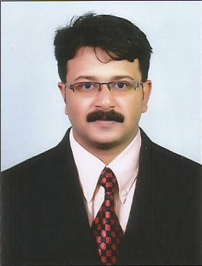
RESUME
JOBISH
C/o-MOBILE: +971-505891826
E-MAIL: jobish.3454134@2freemail.com

OBJECTIVE
To achieve excellence in the field I work,face and overcome challenges with confidence and to utilize my skills to contribute to the organization’s development.
PERSONAL DETAILS
Sex : Male
Age : 33 Years
Date of Birth : 09th May 1983
Marital Status : Married
Religion : Christian (Roman Catholic)
Languages Known : English, Hindi, Malayalam, Tamil, Telugu and Kannada
Nationality : Indian
ACADEMIC QUALIFICATION
MBA - (International Business) : Sikkim Manipal University
DEGREE - (B.A English) : Calicut University
PRE-DEGREE - (Arts) : Calicut University
SSLC : Board of Examinations
EMPLOYMENT DETAILS
Total Work Experience : 9 Years and 7 months for Handling Industrial& commercialTyres to the Domestic & International Markets.
COMPANY | PLACE-COUNTRY | DESIGNATON | PERIOD
YaasTyres LLC | Ras Al Khaimah-UAE | Asst.Marketing Manager | 05.04.2016 to Till Date.
Velox TyresPvt Ltd | Bangalore-India | Marketing Manager | 03.11.2014 to 05.03.2016
Paragon Polymer Products Pvt Ltd | Hyderabad-India | SalesExecutive | 16.07.2007 to 02.11.2014
JOB PROFILE
- Develop and implement marketing plans and projects for new and existing products.
- Liaising with clients.
- Developing & monitoring dealer network & brand development.
- Sales forecasting and achieving the target.
- Handling exports to various countries.
- Product performance study & after sales service.
- Analyzing competitor’s activities and strategies.
PERSONAL SKILLS
- Communication skills.
- Organization and planning.
- Adaptability.
- Decision-making.
- Willing to take on challenging roles and responsibilities.

DRIVING LICENSE
Holding valid UAE driving license (Manual) for light vehicles.

HOBBIES & INTERESTS
Travelling to different places.
Watchingmovies.
Listening to music.
Browsing Internet.

COMPUTER SKILLS
MS Word, MS Excel, MS Power Point, MS Outlook, Internet, E-mail..

DECLARATION
I hereby declare that the above said details are true to the best of my knowledge

