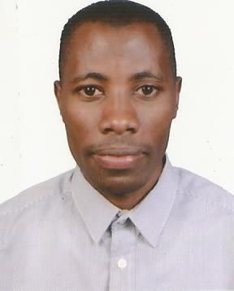
CURRICULUMVITAE
SSENTUMELUUTU

Ssetumeluutu.356061@2freemail.com

PERSONALINFORMATION

GENDER |  | : | Male
NATIONALITY | : |  | Uganda
LANGUAGES |  | : | English,Arabic

CAREERASPIRATIONANDOBJECTIVES

Toobtainemploymentasasalespersontobeabletoputinpracticemygained

knowledgeinsales,exercisethedisciplineofexploringmyskilsandworktothebestof

myabilityforthebenefitofthecompany.

ToworkinacompanywhereIcandeliveralmybestsoastoachievegoodresults

Toperformchalengingtaskswiththehighestdegreeofcompetence

PERSONALATTRIBUTES

- VerygoodincommunicationskilsinspokenandwritenEnglishandArabic

- Flexibleandquicklearner

- Flexibleenoughtohandlechangingenvironments

- Hardworking,confident,disciplined,obedient,honestandresponsible

PROFEESIONALEXPERIENCE

SALESPERSON

ALDHAFRACO-OPERATIVESOCIETY,WESTERNREGION

2012–Present

Dutiesandresponsibilities:

- Greetingcustomerswhoentertheshop.

- Beinvolvedinstockcontrolandmanagement.

- Assistingshopperstofindsgoodsandproductstheyarelookingfor.

- Stockingshelveswithmerchandise.

- Answeringqueriesfromcustomers.

- Reportingdiscrepanciesandproblemtothesupervisor.

- Givingadviceandguidanceonproductselectiontocustomers.

- Dealingwithcustomerrefunds.

- Keepingthestoretidyandclean,thisincludeshoveringandmopping.

- Responsiblefordealingwithcustomercomplaints.

- Workingwithinestablishedguidelines,particularlywithbrands.

- Atachingpricetagsonmerchandiseontheshopfloor.

- Responsibleforsecuritywithinthestoreandbeingonthelookoutforshoplifter andfraudulentcreditcardsetc.

- Receivingandstoringthedeliveryoflargeamountsofstock.

- Keepinguptodatewithspecialpromotionsandputingupdisplays.

.

PROFESSIONALQUALIFICATIONS

- 2011-2011 LAWDEVELOPMENTALCENTER Award–certificateinlaw

ACADEMICBACKGROUND

- 2010–2012 MAKEREREUNIVERSITY

Award– Diplomainbusinessstudies

- 2008–2009 KIBIBISECONDARYSCHOOL Award- Ugandaadvancedcertificateofeducation

- 2004–2007 STEVERESTKYATOSECONDARYSCHOOL Award-Ugandacertificateofeducation

HOBBIES

Playingsoccer-Meetingpeople -Readingcurrentaffair

REFERENCES

- MR.SSUUNAABDUL BranchManagerAIRTELUGANDA Tel:+256772528598

- MR.KASUJJAUNUSU

LecturerMakerereUniversityBusinessSchool

