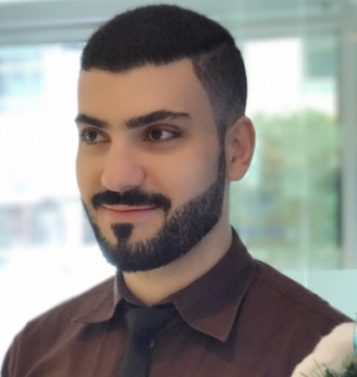  EIHAB  EIHAB.357318@2freemail.com  About Me:  Looking to work and be a part of a corporation, one that believes in its employees’ potential, and help them to improve their skills, to achieve the company’s goals along with employees’ interests.  Also I believe in my ability to innovate and excel in my job.  Skills:  - Administrative skills  - Strong sense of responsibility  - Creative thinking skills  - Self-Motivation & Teamwork  - Initiative & Problem solving  - Attention to Details, Organizing  - Stress management, Flexible  - Ambition, Willpower, Leadership  UAE Driving License  - Nationality: Lebanese  - Birth Year: 1985  - Marital Status: Single  Education:  - Bachelor’s Degree in LAW,  Faculty of LAW, Damascus University, Syria.  Languages:  Arabic: Mother tongue.  English: Excellent at (Speaking, Reading and Writing),  - English Language Certificate:  Ministry of Higher Education, Damascus, Syria.  Computer Skills:  - Excellent computer skills on Windows system and Microsoft Office.  - Computer & Informatics Certificate:  Syrian Computer Society, Damascus, Syria. | Professional Experience:  - May 2015 - Present, Public Relations & Administrative Officer  Jashanmal National Company L.L.C, HR Department  Dubai, United Arab Emirates:  - New, Renew and Cancellation of the Visas and Labour Cards of Employees, through Government websites (Dubai & Abu Dhabi) .  - Government Relations: Performing all types of correspondence with Government authorities, and prepare all the necessary Letters & Applications to issue the Permits, Promotional Campaigns, Special offers and Discounts on the company's products.  - All Jashanmal group Trade Licenses (New, Renew, Cancel, Transfer and Amendments).  - Preparing and submitting all sorts of the applications that related to the Employees cases, and provide the professional and necessary solutions and explanations in each case.  - Preparing and updating all Reports related to work.  - Making the necessary translations for all sorts of Documents, from English to Arabic, and vice versa.  - Renew Company’s Vehicles Licenses, through RTA website.  - Doing all Administrative tasks required and follow-up, at scheduled times.  - October 2012 - March 2015, Banking Observer  Commission Anti-Money Laundering and the Financing of Terrorism  Damascus, Syria:  - Carry out the Observation Tasks on all Financial Institutions (Banks, Companies and Exchange offices), to ensure that they apply the Laws and financial rules, especially operations related to foreign currencies.  - Prepare the necessary Reports that include the Violations and Financial Crimes made by Financial Institutions, and the appropriate Sanctions for each case.  - Contribute in forming the Regulations of Foreign Currencies operations, and ensure that it’s applied legally.  - Prepare continuously Reports about work status, and reporting to the Secretary and the President of the Commission.  - Prepare and Carry out the necessary meetings with other Government Agencies, to put joint working mechanism to adjust the Financial Market under the Laws and Financial Rules.  - Doing all Legal and Administrative tasks required and follow-up, at scheduled times.  - August 2011 - October 2012  Employee at Directorate of Legal Affairs, Central Bank of Syria  Damascus, Syria:  - Conducting legal research and studies.  - Providing professional opinions and solutions to the cases which I was assigned for.  - Contribute in forming the Regulations of Foreign currencies operations, and suggest the penalties over parties who failed to comply, according to the Laws and Rules.  - Formulation and Examine the contracts that will be signing by the Central Bank of Syria.  - Doing all Legal and Administrative tasks required and follow-up, at scheduled times.  - January 2011 - August 2011, Representative of Public Relations  Al-Ramat Company for Tourism and Tourism Marketing  Damascus, Syria  - Representative of Public Relations in communication with families who wishing to enter the field of tourism and tourism investment.  - Providing various offers of tourism, tourism investment, and done a lot of contracts.  - Followed up with the investors inside and outside the company, even after the contracts.  - 2010, Representative of Public Relations  Fairgrounds (Ministries and Institutions Department)  Damascus, Syria  - Representative of Public Relations in communication with the Arab and foreign delegations.  - Accompany the delegations during their travels inside the fairgrounds.  - Provide assistance and explanations necessary for members of delegations.  - 2006 - 2009, Team Leader  Zara Fashion Company, Damascus, Syria  - Helping colleagues and Lead them to work together, and make sure that they are delivering good customer service.  - Ensuring that the staff feels happy, so the business can run smoothly and successfully, which will reflect positively to achieve the target.  - Organize the staff workload and scheduling their shifts, as well as monitoring them to make sure that they are doing well.  - Motivating the staff, meet the expectations, achieve the target.  - Helping with training and development.  - Handling complaints (from both staff and customers).  - Request items, helping with promotional events and some financial tasks like prepare daily sales reports.  References:  - Available upon request…  Regards…

