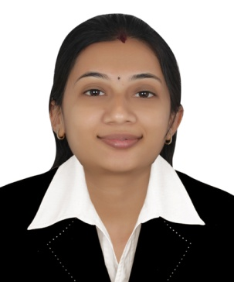
SNEHA
Sneha.357525@2freemail.com

Career Objective:
Highly organize approach, plenty of initiative and a genuine desire to contribute to the ongoing success of the organization.
Career History:
One year UAE Experience working with Everglobal Trading LLC, Dubai as Accountant and Office Administrator.
Duties:
- Handling Accounts like passing entries for purchase invoices, sales invoices, bank.
- Maintaining and filing all records relating to Import and Export.
- Answering incoming calls in professional manner.
- Inquiry with Bank & Buyers about the payments on due dates.
- Organize files both manually and electronically.
- Efficiently resolved many client issues.
- Supported subordinates and taken responsibility of delegated assignments.
- Processed correspondence in relation to customer complaints.
- Answering all the mails promptly.
Key Competencies and Skills:
- Strong work ethic, self starter, result oriented.
- Active team member with self drive and motivation.
- Creative and Innovative thinker.
- Acting with the highest ethical standards and always treating others fairly and with respect.
- Having a practical approach to problem solving.

Academic Qualification:
2014:- CS Final Professional Programme (Group 1) from The Institute of Company Secretaries of India Secured 50.5 %
2012:- Bachelors in Law (L.L.B) from Nalanda Law College, Mumbai University
Secured 55 %

2011:- CS Final Professional Programme (Group 4) from The Institute of Company
Secretaries of India. Secured 50.00 %

2010:- CS Executive Programme from The Institute of Company Secretaries of India.
Secured 55.00 %

2009:- Bachelors in Accounting and Finance from Nagindas Khandwala College, Mumbai University Secured 75.83%
2006:- XII from Nagindas Khandwala College, Mumbai University. Secured 73.00%
2004:- X from St. Lawrence High School, Maharashtra State Board.
Secured 78.13%

Areas of Expertise:

- Financial Administration.
- Filing.
- Reception Duties.
- Ms Office Applications.
- Business Administration.
Beyond Curriculum:
- Awarded as Most Enterprising Student in TY B.com (Accounting & Finance).
- Participated in various Intercollegiate Festivals.

