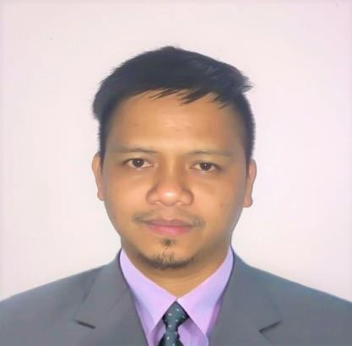
ROCKY

ROCKY.357553@2freemail.com

Personal
Summary A highly motivated and hardworking individual withanexperiencefor more than a year as a Cash Management Associate (Wealth Development Bank) and three years as an AdministrativeAssistant (Santa Barbara Homeowners Association, Inc.), with excellent admin skills and a thorough knowledge of all Microsoft Office programs. I am reliable and dependable and often seek new responsibilities within a wide range of employment areas. I can work well under pressure and adhere to strict deadlines. With professional work ethics as a teammember.

Experience Cash ManagementAssociate

Wealth Development Bank Corporation Cagayan de Oro City, Philippines
May 2015-November 2016

Responsiblefordeliveringasuperbcustomerserviceexperiencetoour clients. The Cash Management Assistant will perform assigned duties under the general supervision of the BranchManager.

Duties:
- Cash handling: Accurately process customer cash,check, transfer, and statement transactions, with a balanced or reconcileddrawer.
- Customer service: Greet and guide customers in a friendly and professionalmanner.
- Electronic Funds Transfers: Process recurring anddaily electronictransactions.
- Handling general clerical duties: filing; photocopying;preparing correspondence; answering telephone; and dataentry.
- Assisting clients with theirconcerns.
- Pick up deposit fromclients.
- Pick up cash assistance from depositorybank.
- Maintaining customer accounts andfiles.

- Prepares weekly, monthly, and quarterly reports from thebank operations.
- Accounting.

Administrative Assistant

Santa Barbara Homeowners Association, Inc. Cagayan de Oro City, Philippines
September 2012-May 2015

Responsible for being the first point contact for the developer, contractors, landlords, and tenants and ensuring that each concern will be dealt with properly.

Duties:

  - Keep records of the homeowner, tenants, contractors,and maintenance stafffiles.
  - Provide advice and assistance to homeowners andtenants.
  - Dealing with any property maintenancerequirements.
  - Managing suppliers and third partycontractors.
  - Dealing with the transactions of the daily operations of the subdivision.
  - Ensures that all the necessary permits, license, taxes, and other matters are properly prepared, processed and paid before it’sdue.
  - Reports to the association officers in a daily, weekly,and monthlybasis.

Education Bachelor of Science Major inManagementAccountingLiceo de Cagayan University, Cagayan de Oro City, PH Graduate. March2012

Personal Information | Date of Birth: | 21st July 1985
 | Gender : | Male
 | Nationality : | Filipino
 | Languages : Visa Status : | English and Filipino  Tourist visa valid until 9th May 2017

I hereby certify that all the above information is true and correct through the best of my knowledge and belief.

