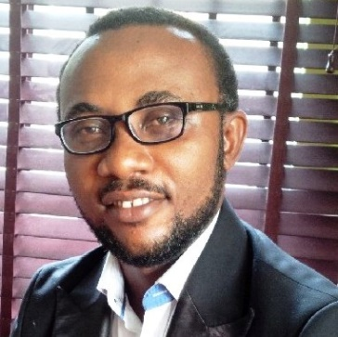
IZUAKOLAM
IZUAKOLAM.357623@2freemail.com

Professional summary: I bring 10years’ experience in Civil/Structural engineering, cost and procurement management and contract administration to an organization. Am a strategic and 360-degree leader and recognize there is no 'I' in project delivery hence am a team player with great vertical and horizontal working relationship.
I improve myself on minute basis, and I bring this attitude to a team and to an organization. WE CAN ALWAYS DO IT BETTER AND SMARTER
I am Resilient, focused, and a driven personality, and would always want to work in an organization and with people that know what they want and willing to give there ALL until the finished line is crossed. I am motivated by challenges and believe that IF IT IS CONCEIVABLE, IT IS BUILDABLE.

Career Objective: To continuously improve and advance my technical and managerial skills for the delivering of projects to ALL stakeholders’ satisfaction.
To always be a team player laterally and longitudinally in an organization for organizational healthy growth.

Work Experience KKROLANDS Limited 2012-2016

My responsibilities were:
- Project Management and Supervision of large scale project (Roads, Canals & Drainages, High-rise >=G+10, warehouse & factory buildings, Jeties etc.)
- Contract documentation review, project scheduling and project planning.
- Making sure that construction works are in compliance to design and construction works are in sync with Method Statement.
- Ensure HSE policy are at ALL times adhered to by both works and visitors as well making sure there is proper House Keeping at ALL times
- Cost and procurement planning.
- Progress documentation and report
- Quality Assurance and Control.

PROJECT+POTENTIALS Limited 2007-2012

My responsibilities were:
- Development of Conceptual Design options
- Infrastructural planning and supervision.
- Structural Design and analysis of different conceptualized design options. (STEEL & CONCRETE)
- Pavement design (Rigid and Flexible) and drainage systems and network
- Preparation of approval & construction documentations
- Represents organization in site/technical meetings.
- Writing and issuing technical reports.
Computer skill

Education FEDERAL UNIVERSITY OF TECHNOLOGY, MINNA.
(B.Eng Civil Engineering 2007.)
COUNCIL FOR THE REGULATION OG ENGINEERING IN NIGERIA (COREN CERTIFIED R.25357) Highest Engineering regulatory body in West Africa.
SOME SUPERVISION PROJECT PICTURES

