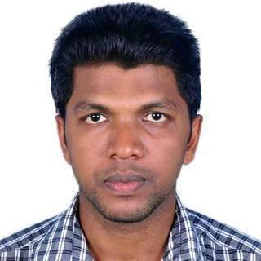
RESUME

UMAR
.umar.357738@2freemail.com

CAREER OBJECTIVES:

Seeking a position to utilize my skills and abilities in the field that offers professional growth while being resourceful, innovative and flexible

ACADEMIC DETAILS:
EXAMINATION DISIPLINE/ |  | SCHOOL | BOARD / | YEAR | %
 | SPECIALIZATION | /COLLEGE | UNIVERSITY | OF
 |  |  |  | PASSING
M.C.A | Computer Application | C.C.S.I.T calicut | Calicut | 2014 | 69.9
 |  | university campus
B.Sc | Computer Science | E.M.E.Acollege, | Calicut | 2011 | 82.5
 |  | Kondotty
HSc | Science + Mathematics E. M. E. A hss, |  | Kerala | 2008 | 82.5
 |  | Kondotty
S.S.L.C | All | Markaz hss, | Kerala | 2006 | 80.5
 |  | Karanthur

ACADEMIC PROJECS:

For BSc.Computer Science

Project Name : Hospital Out Patient System
Language/Platform : C# .NET as front end, SQL2005 as back end

For MCA (Mini Project)
Project Name : Online Magazine

Language/Platform : PHP as front end, MYSQL as back end

For MCA (Main Project)
Project Name : Evento – event listing and management system
Language/Platform : Parse cloud using node.js

TECHINICAL SKILLS:

html, css, javascript, php, SQL

ACHIEVEMENTS:

Winner in calicut university arts fest
EXPERIENCE:

- Worked as a Higher Secondary Computer Science teacher in Government Higher Secondary school Vazhakkad ( 01/06/2015 to 29/02/2016 )
- Worked as Vocational teacher in Computer Science and Informaation technology in Government VHSS cheleari on daily wage basis ( 01/06/2015 to 25/10/2016 )

PERSONAL PROFILE:

Name : Umar

Father’s name : Abdul Azeez.pk

Sex : male

Marital Status : Single

Nationality : Indian

Languages Known : English, Malayalam, Hindi and Urdu

Declaration:

I hereby declare that the above mentioned information is correct up to my knowledge.

