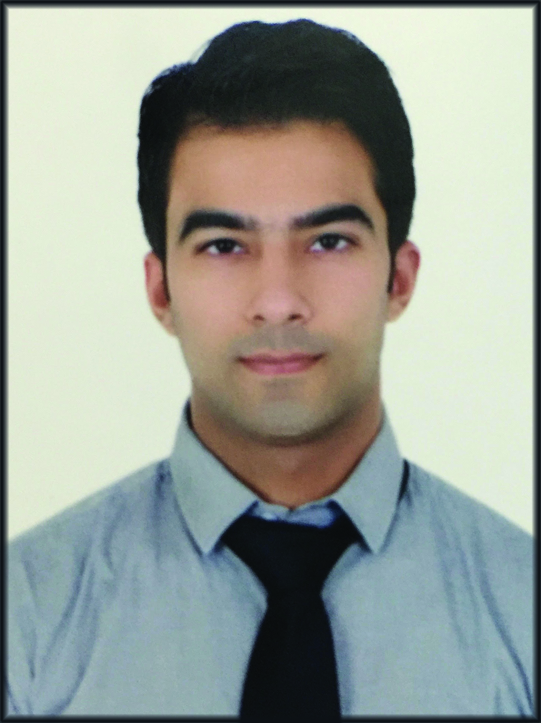
Nikhil

Nikhil.369079@2freemail.com

Address: Currently in ABU DHABI

Seeking an opportunity to utilize and enhance my interpersonal & analytical skills, contributing in the team overall performance and therefore, consequently improving on my own professional standards.

Employment Details:-
Jan 2017 till date in Local General Contracting in ABU DHABI as a Business Developer

Currently working in a Man Power Supply Company in ABU DHABI here I am responsible for the safety of labour, looking for new work, follow up for payment and audit.

Key Deliveries

- Looking for the new projects.
- Completion of all the documents (time sheets , payment certificate) .
- Follow up for the payment after the document completion.
- Looking for Queries and Problems of all the Labours .
- Maintain all the documents of sub-contractor and labours
- Audit all the documents (invoice, daily financial reports)

May 23, 2014 to May 8, 2016 in BA continuum India Pvt. Ltd. (A nonbank subsidiary of Bank of America) as Team Member

Worked in Bank of America Gurgaon, India as part of the Global Wealth and Investment Management Operations, responsible for Banking Brokerage and Custody Services which includes comprehensive and schematic understanding of check stopping of office managers checking accounts, possible fraudulent activities related to checks and Dividend checks issued by bank branches.

Key Deliverables

- Banking Brokerage and Custody Services -

- Stop payments on office managers checking accounts and auto dividend checks.
- Deals with fraudulent activities (pay without issue).
- Working parallel with branches regarding the checks
- Handling calls from outside banks regarding check issuance
- Fetching and maintain reports for office managers checking accounts and auto dividends checks
- Maintain and providing details regarding cash checks
- Embedded coach and responsible for maintaining the SOPs with the new updates as subject matter expert (SME).
- Imparting training to the new associates.
- Responsible for Quality Assurance in the entire process.

- Haute Couture -

- Handling all the sales of the day.
- Maintaining stocks , dealing with staff, whole sellers, dealer, Rent /CAM (common area maintenance)
- Providing customer services and maintains cordial relation with the customers.

Career Conspectus:-
- An enthusiastic professional with an experience of approx. Two years in corporate sector complimenting with scholastics – BBA.
- High commitment on task assigned, time bound & result driven approaches gives an edge.
- A client oriented efforts, cooperative team player and able to work under pressure is distinguishable feature.
- Dedicated towards own and teams performance and belief in collaborative efforts.

Academia:-

Bachelors of Business Administration (BBA) from Guru Jambeshwar University, Hisar, 2009 –2012 with 52%.

Class 12th in Commerce from Kamal Public School, New Delhi, C.B.S.E. in 2009 with 52%.

Class 10th in Science from Cambridge Foundation School, New Delhi, C.B.S.E. in 2007 with 52%.

Technical skills

Operating System: Windows XP, Vista
IT Tools and Application: Microsoft Outlook, Word, Excel (2003-2007), PowerPoint and Internet

Personal Abridgement:-

Management skills | - Analytical and problem solving skills, handling People, time management.
Organisation skills and competence | - Having a self-development mind-set.  - Skilled at composing, editing, expressing and presenting information.  - Ability to unite and mentor groups.

Hobbies:-

- Dancing
- Playing Cricket
- Modelling

Personal Details:-
Date of Birth : 04th July 1990
Father’s Name : Late Mr. Mukul Batra
Language Known : English, Hindi
Weight : 75
Height : 175 cms
Nationality : Indian

