Shreyas.359714@2freemail.com

Single

1990-09-10

Indian
Challenging career in an environment, which would provide me an opportunity to widen my knowledge and utilize it for betterment of Technology, Industry and Society.

Obtained client information by answering telephone calls; interviewing clients; verifying information.
Determined eligibility by comparing client information to requirements. Established policies by entering client information; confirming pricing.

Informed clients by explaining procedures; answering questions; providing information. Maintained communication equipment by reporting problems.
Maintained and improved quality results by adhering to standards and guidelines; recommending improved procedures.
Updated job knowledge by studying new product descriptions; participating in educational opportunities.
Accomplished sales and organization mission by completing related results as needed.
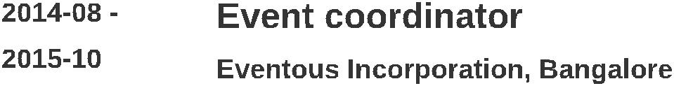

Involved in development, production and delivery of projects from proposal right up to delivery.
Delivered events on time, within budget, that meets expectations. Communicated and maintained timelines and priorities on every projects Communicated, maintained and developed client relationships

Managed supplier relationships

Managed operational and administrative functions to ensure specific projects are delivered efficiently
Traveled to onsite for inspections and project managing events Was responsible for promoting projects budgets from start to finish.
Ensured excellent customer service and quality delivery
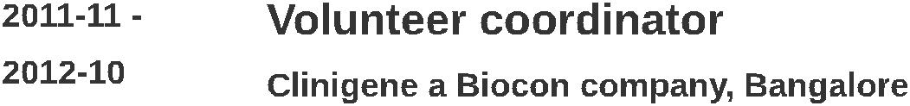

Prepared source data for computer entry by compiling and sorting information; establishing entry priorities.
Processed customer and account source documents by reviewing data for deficiencies; resolving discrepancies by using standard procedures or returning incomplete documents to the team leader for resolution.

Entered customer and account data by inputting alphabetic and numeric information on keyboard or optical scanner according to screen format. Maintained data entry requirements by following data program techniques and procedures.

Verified, entered customer and account data by reviewing, correcting, deleting, or reentering data; combining data from both systems when account information is incomplete; purging files to eliminate duplication of data.

Tested customer and account system changes and upgrades by inputting new data; reviewing output.
Secured information by completing data base backups.

Maintained operations by following policies and procedures; reporting needed changes.
Maintained customer confidence and protects operations by keeping information confidential.
Contributed to team effort by accomplishing related results as needed.
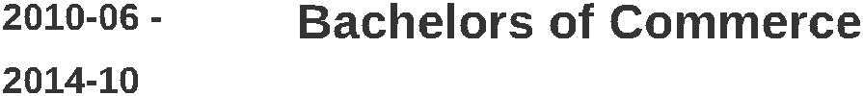

Completed B.COM in Distance Education from Bangalore University.

PROJECT

Evaluation of Market Readiness for Radio Advertising in Radio Siddartha 90.8, Tumkur

