Saurabh
A result-oriented professional targeting middle level assignments in Client Relationship Management/Design Engineering/Manufacturing Operationswith an organisation of high repute
Location Preference: Gulf Cities/US /PAN India

Saurabh.359854@2freemail.com

Core Competencies  Client Relationship Management  Manufacturing Operations  Product Development  Operations Management  Product Designing  Design Engineering  Service Delivery  Business Development  Team Management |  | Profile Summary  A competent professional with nearly 4 years of experience in Customer Service and over 3 years in Engine Design & Development. Knowledge of designing & developing Engine Components. Spearheaded the complete product development cycle starting from product design, tool design, manufacturing, assembly, integration, and so on. Proficient in managing business operations encompassing customer relationship management, day-to-day activities of administrative functions. Skilled in working in fast-paced, high-tech environments requiring skills in management, team building and training. Ensuring customer satisfaction by achieving delivery of service quality norms. Executing policies & procedures in the operating systems to achieve greater customer delight.  Education  Pursuing M.Tech. (Automobile and Engine Technology) from University of Stuttgart, Germany  B.Tech. (Mechanical Engineering) from Punjab Technical University, India  12th from Sacred Heart Sr. Sec. School, Ludhiana  10th from DAV Public School, Ludhiana
Career Timeline
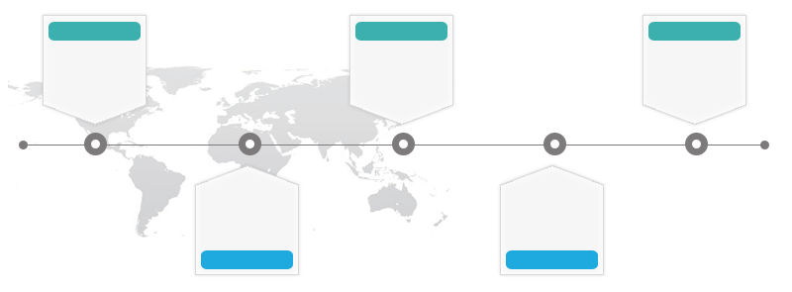
AMCO Industries, Ludhiana
Jul’11-Dec’11

Mann + Hummel GmbH, Ludwigsburg, Germany
Feb’15 – Jan’17

Oct’13-Present
Persian Restaurant, Stuttgart, Germany

Aug’13-Sep’14
Rennteam Uni Stuttgart e.V., Stuttgart, Germany

Jan’08-Dec’10
Balwindra Tools Pvt. Ltd., Ludhiana

Work Experience
Oct’13-Present
Persian Restaurant, Stuttgart, Germany as Manager-Customer Service
Key Result Areas:
- Improving customer service experience, creating engaged customers and facilitating organic growth
- Taking ownership of customers issues and following problems through to resolution
- Setting a clear mission and deploying strategies focused towards that mission
- Developing service procedures, policies and standards; keeping accurate records and document customer service actions and discussions
- Responding to telephone inquiries, providing quality service to customers and associates inquiring about the availability of products or status of orders; analysing statistics and compiling accurate reports
- Ensuring the highest standards of food service w.r.t. Health & Safety management while adhering to hygiene procedures & standards
- Communicating with the kitchen staff to ensure efficient food service
- Recruiting, mentoring and developing customer service agents and nurturing an environment where they can excel through encouragement and empowerment
- Keeping ahead of industry’s developments and applying best practices to areas of improvement
- Controlling resources and utilising assets to achieve qualitative and quantitative targets
- Adhering to and managing the approved budget; maintaining orderly workflow according to priorities

Significant Accomplishments:
- Measured employee satisfaction using methods and recommended initiatives towards enhancing efficiency levels
- Supervised all activities and led various initiatives which helped the Restaurant in receiving the Award of Excellence from TripAdvisor

Feb’15 – Jan’17
Mann + Hummel GmbH, Ludwigsburg, Germany as Work-Student
Key Result Areas:
- Executed development and construction of new Test Beds for Liquid Filters
- Performed digitization of hand drawings and sketches in CATIA V5 and storage them in Database (CIM Database); set-up of a standardized system to provide technical Drawings worldwide
- Altered or modified designs to obtain specified functional or operational performance

Aug’13-Sep’14
RennteamUni Stuttgart e.V., Stuttgart, Germany as Team Member: Engine Development
Key Result Areas:
- Engaged in designing, development, construction & simulation of valve drive & valve components as part of a engine development

Jul’11-Dec’11
AMCO Industries, Ludhiana as Quality and Inspection Engineer
Key Result Areas:
- Approved incoming materials by confirming specifications; conducted visual and measurement tests; rejected and returned unacceptable materials
- Documented inspection results by completing reports and logs; summarizing re-work and waste; putting data into quality database
- Performed all daily inspection and test of the scope and character necessary to achieve the required in the drawings and specifications
- Kept measurement equipment operating by following operating instructions; calling for repairs
- Maintained safe & healthy work environment by following standards and procedures; complied with legal regulations
- Developed and conducted a variety of tests on inbound materials from vendors and outbound products for shipping; accomplished quality and organization mission by completing related results as needed

Significant Accomplishment:
- Recommended training programs for new joinees; ensured that trainings delivered to the team were put into effect and feedback was given on the program success, thereby ensuring a transparent review of acquired talent

Previous Experience
Jan’08-Dec’10
Balwindra Tools Pvt. Ltd., Ludhiana as Work-student
Key Result Areas:
- Administered development & construction of spanners, grease gun and oil splash jug
- Performed quality control of produced tools

Internship
Organization: RICO Auto Industries Pvt. Ltd., Gurgaon, India
Period: Jan’11-Jun’11
Area of Exposure:
- Production Department: Production of Cylinder Heads
- Application of CAD/CAM
- Engaged in the development of alloys

Other Courses
- Intensive German Language Course (Completion C2 &TestDaF) from Carl DuisbergCenter Cologne in 2012
- Basic Course in “Pro-Engineering” from Centre for Development of Advanced Computing, Mohali in 2009
- Introduction semester in Automobile Technology from Cologne University of Applied Sciences in 2012-13

IT Skills
Operating System: Microsoft Windows 7/10, Mac OS MS
MS Office: Word/PowerPoint/Excel
Programming Language: Basics in C
Design Programs: AutoCAD, Pro-E, CATIA V5 Product Management: CIM Database

Extracurricular Activities
- Participated in National Service Scheme (NSS), Youth-Fest Zonal’09 &’10 (Third and First Place) and in Cricket (U-19 State Level Cricket Championship’05)
- Organized Blood Donation Camps and Trekking-Camp with “Bharat Scouts & Guides”

Personal Details
Languages Known: English, German, Hindi, Urdu and Punjabi
Present Address: Dubai, UAE

