MOHAMED

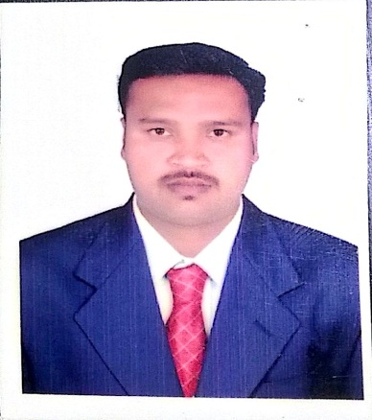
CAMP BOSS

MOHAMED.360492@2freemail.com
OBJECTIVE

To use my skills and knowledge to contribute towards developing and expanding business opportunities, with the chance to advance to a management role in future
EDUCATION

ACADEMIC YEAR | GRATUATION | UNIVERSITY
2003-2006 | BSC- HOTEL MANAGEMENT | BHARTHIDASAN UNIVERSITY, TAMIL NADU- INDIA

COMPUTER PROFICIENCY

- M S Office
- Internet Application

WORK EXPERIENCE
Designation : CAMP BOSS
Organization: Tafseer Contracting Company,
Abu Dhabi, UAE.
Tafseer Contracting Company is a part of Royal Group and a growing construction company in UAE. It has executed a diverse portfolio of real estate and infrastructure projects. Today the company encompasses an array of plants and state-of-the-art equipment as well as multinational team of highly qualified staff. Tafseer's position as a growing contractor is backed by the company's strong ownership structure & resource base with investments in plants, equipments and expertise. It is a Construction & Maintenance Company having 6000+ employees including regular, contract, temporary, consultant & trainee, proud to be working under ISO Registered Company

HOTEL MANAGEMENT EXPERIENCE

. JEET building cont. L. L. C worked as a camp boss

- Rawaby food stuff co. Kuwait worked as a admin asst.

- Hotel Taj Connemara Chennai worked as a banquet head waiter

- Hotel Best western gdermanus Madurai worked as banquet captan

LANGUAGE PROFICIENCY
Verbal: English, Hindi, Urdu, Tamil, Malayalam, Arabic
Written: English, Tamil

ACHIEVEMENT
National level player in shuttle badminton and gold medleys’ in state level competition
PERSONEL DETAILS
Date of Birth : 15th May 1986
Marital Status : Single
Nationality : Indian
Gender : Male

DECLARATION:
Hereby i declare that all statement made in this application are true, complete and correct to the best of my knowledge and belief.

. Jeet building cont. L.L.C. WORKING AS A CAMP BOSS

