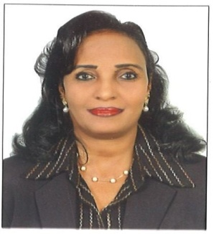
c.v
PERSONAL INFORMATION

Name: Atiat
Atiat.360837@2freemail.com

Personal Statement
A well-educated and highly knowledgeable professional with over 7 years of extensive experience gained on an international basis. An expert in the field of secretary and HR with a very good computer skills and business administration knowledge. Having quickly and successfully progressed through my career I have gained a vast amount of knowledge and experience that I am looking forward to apply it to new situations. Currently looking for a challenging new position that will allow me to both utilize and further develop my existing skill set. I am punctual and serious when it comes to work and very social personal, always has an interest in keeping with the new department, dynamic, confidant & self-motivated, affectively managing time & stress, take responsibilities, ability to share opinions and solve problems, open minded to new and fresh ideas, and always eager to learn more.

EDUCATION AND COURCES
- Diploma of Secretary Since & Public Relation- Omdurman Ahalya University.

COURSES AND TRINING:
- Computer course from computer technology institute.
- Advance MS word.
- Introduction &Operation.
- Programming Fundamental & basic.
- Power poin.
- Excel programming.
- Telex course form institute of technical studies.
- Basic passenger fares and ticketing.
- Diploma 3 years in marketing at Hai EL-Dubat Commercial high school.
LANGUAGES
- Arabic: Fluent Orally & Written (Mother Language)
- English: Good Orally & Written

WORK EXPERIENCE

UAE:

- RIVER THAMES GENERAL TRADING COMPANY - DUBAI

- Two years as customer service and PRO
I have experience in renewing residency, passports for the company's employees and renewal and issuing licenses from the Economic Department. In addition of helping the public relations manager and follow up all the secretary and office administration work.

- PLUS POINT BUILDING MATERIALS L.L.C - DUBAI :-

- Two years as secretary
Follow up of quotation, orders, invoices &payment.
Follow up the shipping of the documents & goods plus the customs.
Follow up all the secretary and office administration work.
Regular visits of potential customers.
Work expiration the personnel regulation with Ministry Of labor, visa issuing and canceling, opening Bank Accounts, outdoor jobs relating to Director manager.

- AL WAFAA GENERAL TRADING L.L.C- DUBAI

    - Two years as receptionist , customer service and sales
Overseas:

- One year experience as call center in Zain company-Sudan.
- Two years' experience as sales administrative at sales & marketing department in balance general treading company-Sudan.
- Two years as assistant teacher in Algabss International School-Sudan.
- MONIEM IND. AND ENG. COMPANY LTD- SUDAN:-

    - Seven years’ experience as secretary & PRO
Day-to-Day office duties.
Maintain document tracking and filling system and update records.
Organize and prepare filing for meetings and making filing systems, sorting, locating document and registration information in the internet.
Personnel office in charge of all “HR” activities for the company resolving staff problems Appling the policy and practices and help in reparation of the budget plus other related work.

REFERENCES
- Available upon request

