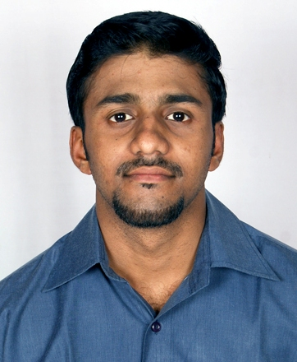
361007@gulfjobseekers.com

Career Objective

To achieve high carrier growth through a continuous learning process and keep myself dynamic, visionary and competitive with the changing scenario of the world.

Work Experience

Organization : Shapoorji Pallonji & Co. Pvt. Ltd (CMG)
Duration : From Jan 2014 – Till Jan 2017 (3 years)
Designation : Officer Accounts
ERP Application : Oracle ERP 11i/12i, SAP 6.0 (MM module)

Job Profile:

- Centralized Work Order creation and amendment in Oracle and SAP.
- Vendor creation and updating in the system.
- Creditors/ Debtors L edger Reconciliation.
- Invoice parking and posting in the system.
- Coordination and follow up with vendors for quotations and prepare the comparative statements so as to finalize the rates.
- Generated MIS reports related to work order.
- Proper documentation for all work orders released as per audit requirement.
- Physical inventory check at warehouse with the system report for audit purpose.
- Knowledge of taxation like Service tax, Vat.
- Providing user interface training to the site team.
- Coordinating with the site team for DPR of the Projects.

Projects Undertaken

- Summer Project (May-June 2012):- Study made on construction and its activities.
Key result areas: Procedure of projects, contract types, modules, balance sheet and cash flow analysis.

- Winter Project (Jan–Feb 2013) :- Critical analysis of Microfinance in India

Key result areas: Role of microfinance, activities in microfinance, comparative analysis, SWOT analysis.

Education

Education | Board/University | Year
Master in Management Studies (MMS) in finance | Mumbai University | 2011-2013
Bachelor of Commerce | Mumbai University | 2007-2010
Higher Secondary Certification | Maharashtra Board | 2005-2007
Secondary School Certification | Maharashtra Board | 2004–2005

Certification

- Certification Course in BCFMA ( BSE Certified Financial Markets Associate)
- Certificate of SAP in MM module
- Certificate of PACE (Program Assisted Computer-Data Entry), Computerized Financial Accounting, D.T.P. MS Office.

Leadership Positions Held/Awards & Achievements

- Coordinator for Annual Day, SFIMAR.
- Coordinator at Personality Development Camp, GG College.
- Core Team Member for SAP Implementation of MM Module for Work Order.

Extra-Curricular Activities

- Participated in Personality Development Camp, held at St. Gonsalo Garcia College, Vasai.
- Participated in dance competition for Annual day held at St. Gonsalo Garcia College, Vasai.
- Participated in football matches for St Francis Institute of Management & Research and for Shapoorji Pallonji & Co. Pvt. Ltd

