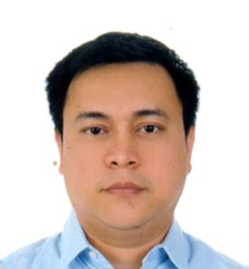
gene.361979@2freemail.com

Objective: To be able to work in a progressive organization which provides opportunity to enhance, improve, and utilize my knowledge, skills, and expertise while attaining personal and career growth.

Experience: October 2011- Present,Homes r Us,LLC. –Lalsgroup, Dubai, UAE

Store of Excellence Showroom Manager
- Manages the store operations and merchandising activities of the pilot store
- Responsible for maximizing retail sales and operating profit of the store
- Develops and manages the service environment and presenting a clean, neat, and organized shopping environment for the customers
- Leads the Core team in formulating, developing, and applying new ideas in the store
- Oversees the documentation and implementation of the SOPs
- Trains all the staffs in Soft skills and Job skills
- Enrolls all the staffs in trainings of Customer Service, Selling Skills, Communication Skills, Leadership Skills, Product Knowledge, etc.
- Improves systems and develops new standard operating procedures
September 2008– September 2011,Homecentre, LLC.-Landmark

Asst. Showroom Manager
- Acted as Duty Manager in the absence of the Showroom manager
- Monitor the handling of customer complaints in line with company policy.
- Mentored, coached, and trained the staffs and other managers regarding all aspects of the furniture and household departments
- Functioned as the In-house trainer in all the aspects of skills and product knowledge training

Experience: January 2006– August 2008,SM Department Store, Philippines
Department Manager cum Training Manager
- Act as a Duty Manager in the absence of the Operations Branch Manager
- Act as an Auditor
- Train all the staffs in Customer Service, Selling Skills, Communication Skills, Leadership Skills, Product Knowledge, etc.

February 2002 –July 2005 Bahrain Building Materials, Bahrain

Safety Manager
- Worked as a Safety Engineer and was promoted as a manager in confined space workstations
- Act as the Safety trainer and auditor

Education 1996-2001 University of San Carlos Cebu, Philippines

Bachelor of Science in Industrial Engineering

1994-1996University of Cebu Doctors’, Cebu, Philippines

Bachelor of Science in Physical Therapy

Certificates Planning and Organizing – Homes r Us
Leading and Motivating – Homes r Us
Selling Skills - Homes r Us
Customer Service – Homes r Us
Communication Skills – Homecentre
Effective Selling – Homecentre
High Potential Development Program – Homecentre

Interests Seminars, Books, and Public speaking engagement.

References Available on request.

