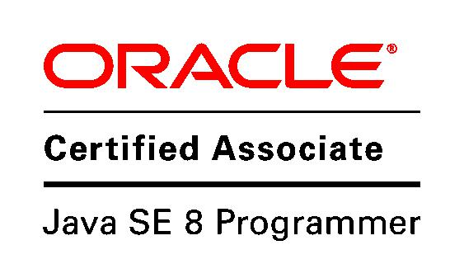
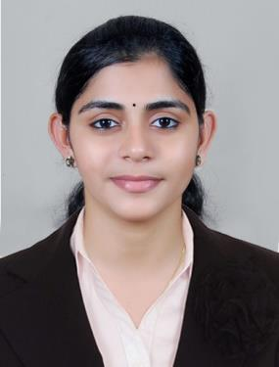

Ancy
Ancy.362581@2freemail.com

Objectives

To put my learning and experience to use, and utilize my skills to the fullest and thereby achieve my highest potential and support the growth of the organization

Career Summary

- Overall 3 years of experience in Web development using JAVA and JSP.

- Oracle Certified Associate, Java SE 8 Programmer (OCAJP SE8 1Z0-808)

- Proficiency in Java, J2EE, C++, HTML5,Java Script,AJAX,JQuery, JSON ,JSP, and JSTL .Back ends MySQL, Oracle etc.

- Extensive knowledge in frameworks like Hibernate 3.0 and Spring.

- Strong Object Oriented concept

- Knowledge of Eclipse tool for the development of Java projects.

- Cohesive team worker, having strong analytical, problem solving and interpersonal skills.

Experience

Software Engineer (October 2014 – February 2017 )

Pi Serve Technologies Pvt. Ltd. Cochin, Kerala

- Company Profile: PiServe is a leading service provider of application development and remote infrastructure management for more than a decade. PiServe's vision is to make software and provide IT services very affordable for the hundreds of thousands of businesses worldwide.
- Platform: Java, Spring,,Javascript,HTML5,jSON,AJAX,JQuery,MySQL

- ORM Tool: Hibernate

- Database: MySQL, XAMP

- Distributed/Web Environments: Tomcat 5.0.

Software Engineer (February 2014 – September 2014)

ARICENT Technologies Chennai, India

- Company Profile: - Aricent is a pure-play product engineering service and software firm. It develops software, provides technology services, and works with networking, telecom, software, semiconductor, Internet, and industrial companies

- Platform: C,C++,JAVA

- Technical Expertise: Networking,DataStructure

- Project Summary: The Cisco Carrier Packet Transport (CPT) System is the first Packet-Optical Transport System (P-OTS) built on standards-based Multiprotocol Label Switching Transport Profile (MPLS-TP) technology.

Education

BTech Computer Science Engineering (2010 - 2013) SCORE:73.69%

Sree Narayana Gurukulam College of Engineering Kolenchery, Ernakulam, Kerala

Affiliated to Mahatma Gandhi University, Kottayam

Diploma in Computer Science Engineering (2007 - 2010) SCORE:78.6% Govt. Polytechnic college, Kalamassery Ernakulam, Kerala

State Board of Technical Education and Training Kerala

Plus Two (2005 - 2007) Score 79.50%

Mar Elias Higher Secondary School Kottappady, Ernakulam

State Board, Kerala

Class 10 (2004 - 2005) Score 89.73%

St.Augustine’s Higher Secondary School Kothamangalam, Ernakulam

State Board, Kerala

Additional Qualification
- Oracle Certified Associate, Java SE 8 Programmer Certified in March 2017.

- Successfully completed 3 month PRISM Training program conducted by NALANDA Training center , Aricent.

- Three day db2 training program by IBM and got certified as IBMdb2 associate.

Functional Expertise
- JAVA Programming (Core Java,JSP)

- Spring, Hibernate, JQuery

- JavaScript,HTML5

- JSON

- C,C++programming

- Object Oriented concepts

- Networking Protocols ISO OSI,TCP,UDP,IP

- Knowledge in IP V4 and IP V6 Sub netting and Super netting and classless addressing

Technical Skills

 | Operating System | : | Windows, Linux
 | Language | : | JAVASCRIPT,HTML5,JSON,C, C++, JAVA, JSP, PHP
 | Frameworks | : | Spring, Hibernate, structs
 | Networking Protocols | : | TCP,UDP,IP,RIP, OSPF, DNS
 | Database | : | My SQL, Oracle, MS Access, DB2

 Software Engineering Tools : CASE Tools, Visual Paradigm

Academic Projects
- A METHOD OF USER AND INFLUENCE IDENTIFICATION FROM MULTIPLE

SOCIAL MEDIA NETWORKS
  - Domain: Data Mining

  - This project use a Friend Relationship-Based User Identification algorithm for identifying identical users from different Social Media Networks and build influence evaluation model using two aspects, relationship and activity .

  - Front end: JAVA

- TRAINING AND PLACEMENT DEPT. OF COLLEGE

  - Project was aimed at developing an online application for the Training and placement Dept. of the college.

  - Some features of the system will be creating vacancies ,storing applicants data, Interview process initiation ,scheduling interview ,storing interview results ect..

  - Front end: JSP

  - Back end: MySQL

Extracurricular Activities
- Conducted college level events as part of the College Organizing Committee.

Core Competencies
- Good Communication Skills

- Continuous Learning

- Project and Task Management

- Good team player

- Strong and quick in acquiring new technologies

Personal Details

 | Date of Birth | : 20 January 1990
 | Sex | : Female
 | Marital Status | : Single
 | Nationality | : Indian
- Languages known : English, Hindi, Malayalam

I, Ancy declare that the above-furnished statements are true and correct to the best of my knowledge.

