FAISAL
Faisal.362840@2freemail.com

Personal Details:
Nationality : Sudanese
Gender : Male
Martial Status : Married
Religion : Muslim
Visa status : Residence
Other : UAE D/L

Education Qualification

  - Bachelor in Arch. Engineering – Khartoum College of Applied Studies- Sudan -2005.(5 years)
  - Diploma in Auto Cad 2d.
  - Diploma in 3DStudio Max.
  - Membership in Society of Engineers (UAE 2013).
  - Certificate in Quality Project Management – From S.O.E. (UAE 2015).
  - Certificate in Arbitration Procedure Management – From S.O.E. (UAE 2015).
  - Certificate in Construction Contract Management – From S.O.E. (UAE 2015).
  - Certificated ISO 9001:2015 Internal Auditor – From G.I.Q.M (USA 2016)
  - Approved from RAK Municipality as Unlimited Arch. Designer.
  - Good knowledge about Computer science &Microsoft office (word, excel…) & Internet.
Training
    - Training set HamdiConsultancy as Site Consultant Eng. In Teachers Tower. (Khartoum – Sudan _Nov. 2000 – Jan.2001).
    - Period of training at the Giant Trade and Constriction as Site Eng. In many sites of company.(Nov.2001 –Feb.2002)
    - Training for the National Authority for Road and Bridge (Nov. 2002-Jan.2003)
Work experience
- ABIDING, S period of Operation of Enterprise and Investment working as Site Eng. And do some office works like drawing with auto cad and quantities. (Dec 2003 – Jan 2005).
- Amid for Contracting and Consulting Engineering working as Site Eng. In many pleases in Khartoum and as consultant for some sites, also work in of office in drawing with auto cad and 3d max and quantities for company sites. (Feb 2005 – sep2006).
- TRAX for Contracting and Investment work as Site Eng. And quantity and qutation for works of company (Oct 2006 – mar2007).
- SakhrMahmudCompany ltd. Working as Site Eng. For many sites of company in Khartoum and Omdurman (Apr 2007 – apr2008).
- Work in AL JAWDAH AL SHAMILAH GENERAL CONTRACTING in Abu Dhabi- UAE as Assistant Eng. And delegate for company in government revolving& office documents control (quations, invoices …etc) & out door sales (May 2009 – Dec. 2012).
- Work in Excel Eng. Consultants in Abu Dhabi as Engineer collaborator for design and site works (Jan. 2012 – Dec. 2012)
- Work in Visonlogestic contracting in Al ain as Site Eng. (Feb.2013 ….. June 2013)
- Working in Gulf Consulting Engineering Group – RAK –UAE as Branch Manager for UAQ branch & Architect Engineer in supervision department & as design manager & Quality Coordinator from March in RAK branch 2016 ( July 2013…… until now)
Projects
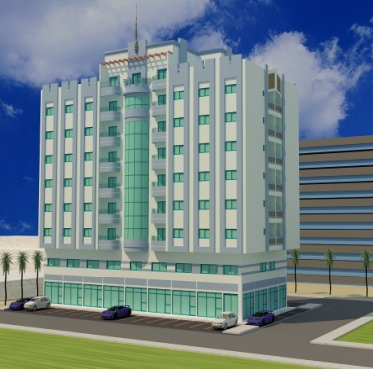
Project Name: G + M + 8 Typ. + R.
Client Name: SH. Saleem Saeed Al Khatrei
Position: Consultant Site Eng. Duty was site
Visit for checking and flow up all work stage
and approved materials and subcontr.
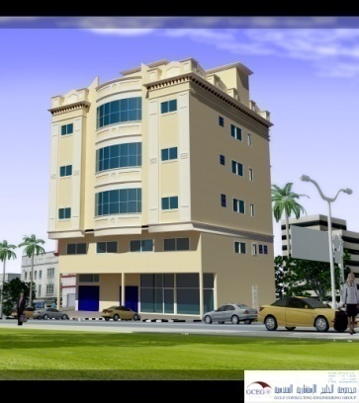
Project Name: G + M + 3 Typ. + R.
Client Name: Amna Abdulrahman
Position: Consultant Site Eng. Duty was site
Visit for checking and flow up all work stage
and approved materials and subcontr.

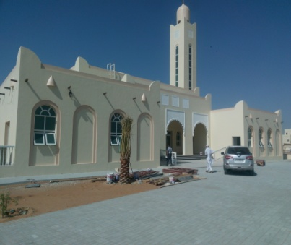
Project Name: Mosque + Imam House
Client Name: GAIA
Position: Consultant Site Eng. Duty was site
Visit for checking and flow up all work stage
and approved materials and subcontr.

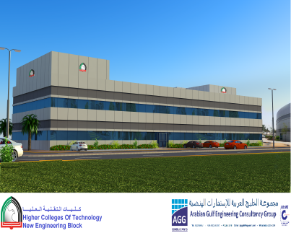
Project Name: G +1 + R ( Lab & Class )
Client Name: HCT ( Women Collage ) - RAK
Position: Consultant Site Eng. Duty was site
Visit for checking and flow up all work stage
and approved materials and subcontr and attend projects meetings.

      - More Villas & Showrooms & Mosques …etc.

Language

- English read , write &speak
- Arabic(mother tongue)

