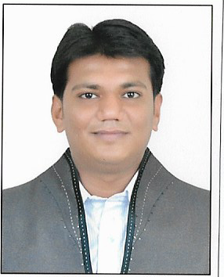 dhanpal.363964@2freemail.com

Dhanpal

Career Objective

Pursue a career that provides an avenue to innovate and apply skills for the growth of self and the organization. Given an opportunity to serve your esteem organization, I assure to perform in the most efficient manner.

Work Experience

1. Havmor Restaurant Pvt. Ltd. [Central Kitchen]

I am pursuing my work at Havmor Restaurant Pvt. Ltd. as a Account Assistant at Central Kitchen branch.
- Duration: Enabled service from June‐2014 to Feb 2017
- Work in SAP. (knowledge of SD user, PP user, MM user, and MGR user)
- Responsibilities:
− Preparing the Bill.
− Administrative work
− Supervision

2. High court Advocate Office [Kaushal Pandya]

I have worked at Advocate office of a High court Advocate [Kaushal Pandya] as a Clerk.
- Duration: Service from July‐2013 to April 2014.
- Responsibilities:
− Administration work
− Accounting work and Typing work
− Keep the knowledge of each running and upcoming case in High Court.
− Keep and maintain the file of each case as per sequence.
− Prepare the progress report of whole case coming in the office.

3. High court Advocate Office [Amit V. Thakkar]

I have worked as a Clerk at Advocate office of a High court Advocate [Amit V. Thakkar].
- Duration: Service from July‐2012 to June‐2013.
- Responsibilities:
− Prepare the progress report of whole case coming in the office.
− Keep and maintain the file of each case as per sequence.
− Keep the knowledge of each running and upcoming case in High Court.
− Accounting work and Typing work

4. Chartered Accountants, Gunvantlal J. Shah & Co.

I have worked as an Audit Clerk at Chartered Accountants office of Gunvantlal J. Shah & Co.
- Duration: From October‐2011 to July‐2012.
- Responsibilities:
To do the Audit of Different Organizations and I have done the Audit of like, − Trusts
− Credit Societies
− High Court
− Co‐operative Banks, Schools.

Projects

1. Kotak Mahindra Bank [Maninagar Branch, Ahmedabad]
I have completed the 15 days Project in Kotak Mahindra Bank [Maninagar Branch, Ahmedabad] related to Loan and Documents verification.
Duration: Held from 23rd May 2014 to 7th June 2014.

Training

1. National Institute of Finance Account [NIFA]
I have taken the training of National Institute of Finance Account course which is based on National accounts fields.
Duration: Held from January 2009 to December 2011.

Educational Qualification

- Passed S.S.C. Examination from Gujarat Secondary & Higher Secondary Education Board, Gandhinagar in March‐2007.
- Passed H.S.C. Examination from Gujarat Secondary & Higher Secondary Education Board, Gandhinagar in March‐2009.
- Passed T.Y. B.COM form Gujarat University in March‐2013.

Computer Skills

- Tally
- MS‐office
- Internet knowledge

Personal Information

 | Name | : Dhanpal
 | Date of Birth | : 11th November 1991
 | Marital Status | : Unmarried
 | Nationality | : Indian
 | Language Known | : English, Hindi, Gujarati.

Thanking you in anticipation,

