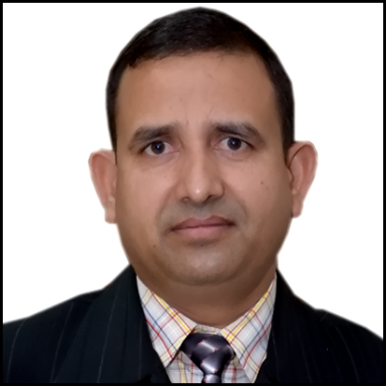
CURRICULUM VITAE
For the post of: Academic Coordinator Middle/Senior school)
Subhash
Subhash.364273@2freemail.com

Career Objective:
To work with an organization which provides me with more opportunities for the growth of personal as well as professional skills?

Self-Description:

I am a post graduate from Aligarh Muslim University, with second class (57%). I have a total experience of 17 years of teaching in Air Force school Jamnagar, Delhi Public Schools. Presently I am working as PGT-HOD (Hindi Department) in a reputed Delhi Public School, Meerut U.P. (India)
Educational History:
Doctorate (Ph.D.) in Hindi pursuing.
January / 2005 - January / 2007
M.A. in Education: Meerut University, Meerut (UP)
June / 1999 - April / 2001
Post Graduation (M.A.) in Hindi: Aligarh Muslim University, Aligarh (UP)
May / 1995 - April / 1996
B. Ed in Hindi & History: Agra University, Agra (UP)
July / 1992 - May / 1994
Graduation (B.A.) In Hindi, History and Political Science: Agra University, Agra (UP)

Professional Experience:

DPS Meerut, west U P from 1st July 2016 to onwards as PGT-HOD Hindi

Bahrain Indian School, from April 2014 to June 2016 as HOD-Hindi. /Asst. Manager Admin

Delhi Public School, Meerut Jan 2014 to April 2014 as PGT-HOD (Hindi)

Birla Public School, Doha QATAR August 2008 — September 2013
PGT - HOD (Hindi)

Delhi Public School, Rewari March 2005 — August 2008
PGT - HOD (Hindi)

Delhi Public School, Bathinda March 2004 — March 2005
TGT - HOD (Hindi)

Delhi Public School, Rajkot June 2002 — March 2004
TGT - HOD (Hindi)

Air Force School, Jamnagar (Gujarat) April 1998 — June 2002
TGT Hindi

U.M. Vidyalaya, Bajna, Mathura (UP) July 1992 — June 1996
TGT

Skills & Achievements:
* Teacher in-charge Scout and Guide at Air Force School, Jamnagar.
* In charge of Hindi Club at DPS, Rajkot
* Examination Coordinator of DPS, Bathinda. Head of Department Hindi
DPS, Rajkot, DPS, Bathinda & DPS, Rewari, BPS Doha Qatar
* Presenter of Hindi Poems on various TV Channels
* Best Hindi Teacher Honors Certificate Award by Rachna Sager
Publication New Delhi.
* Received Certificate of Social service by Care Humanity Foundation
* Received appreciation letter by HPCL on Hindi Phakhwara
* Awarded Best Teacher Honors Certificate for the North Zone from
Scholastic India Private Ltd.
* Certificate of Honor by Embassy of India to Qatar for good work in Hindi
Language Ability: English Fluent Hindi : Excellent
Publications:
Hindi Vyakaran Class 1 to 5 with Pinnacle India Education Publisher New Delhi
Hindi Text cum Workbook Class 1 to 8 As CCE pattern with New Saraswati House (India) Pvt. Ltd New Delhi

Hobbies: Reading books; writing articles, swimming, playing volleyball and Cricket.

